

E-Learning and Practical Training of Mechatronics and Alternative Technologies in Industrial Community
510586-LLP-1-2010-1-SI-LEONARDO-LNW
Multilateral Thematic Networks

UNIVERSITY OF deusto
Introduction to Microcontrollers
E-PRAGMATIC module
Javier García-Zubia and Ignacio Angulo
September 26, 2011

The objective of this training module is to learn the fundamentals of 8-bit microcontrollers. The course covers generic aspects in relation to the market, architecture, peripherals and development of microcontrollers in recent years and delves into the architecture of the Microchip PIC microcontroller manufacturer, leader in 8-bit devices. This module includes real experiments through a remote laboratory in which students may modify the firmware of a mobile robot controlled by the PIC18F4550 microcontroller.

This work has been performed within the project "E-PRAGMATIC; E-Learning and Practical Training of Mechatronics and Alternative Technologies in Industrial Community", 510586-LLP-2010-SI-LNW. This project is funded with support of the Lifelong Learning Programme of the European Union. All here provided information and documentation reflects the views only of the authors, and the Commission cannot be held responsible for any use which may be made of the information contained therein.

Document revision history
Revision | Date of Release | Purpose
1.0 | 1/10/2011 | First Version
2.0 | 27/12/2011 | English translation

Contents
1 Introduction 1
2 8 bit microcontrollers 3
Current market scenario of microcontrollers 3
Microcontroller Evolution 5
Microchip microcontroller catalogue 6
Low-end - Baseline (PIC10MCU and PIC12MCU) 7
Midrange (PIC16MCU) 8
High-end (PIC18MCU) 8
Microchip hardware solutions 8
Microchip software solutions 9
3 PIC18F basic architecture 10
Introduction 10
Main Processing Unit (MPU) 10
Control Unit 11
Arithmetic Logical Unit 12
Buses 14
Registers 14
Data memory 15
Pure Direct Addressing 15
Direct routing through the BSR register 16
Direct addressing through the access bank 16
Program Memory 19
Additional resources 21
Integrated peripherals 22
PIC18F4550 22
4 Assembler for PIC18 23
Introduction 23
Instruction types 23
Byte-oriented instructions 24
Bit-oriented instructions 25
Inmediate addressing instructions 27
Control instructions 28
Data access instructions in program memory 30
Control structures 30
Simple conditional structure 31
Double conditional structure 32
Multiple conditional structure 33
Repetitive structure with undefined number of iterations 35
Repetitive structure with predefined number of iterations 36
Assembler directives 37
Generic label definition file 38
5 The WebLab-BOT lab 38
Introduction 38
WebLab-BOT remote lab architecture 39
Azkar-Bot robot design 40
Robot connection 41
The engines 42
Obstacle sensors 44
Reflection sensor 45
The Bootloader 46
Access to the Weblab-Bot remote lab 49
Experiment 1: Moving the robot 50
Introduction 50
Development of the project with MPLAB IDE 50
Installing the development environment 50
Generating a new project with MPLAB 51
Programming the robot 53
Generating the source file and giving it a name 53
Directivas iniciales 54
Configurando el microcontrolador 55
Controlando el robot 57
Probando el experimento en el laboratorio remoto 59
Solucionando el desastre 61
Experimento 2.- La línea negra 65

Figure List
Figure 1. Worldwide MCU Revenue Trend (source: WATs IC Insight, 2009/03) 4
Figure 2. 2008 MCU Market (Source IC Insight) 5
Figure 3. Microchip MCU portfolio classified by functionality and performance. 6
Figure 4. Microchip "Microcontroller Product Selector". 7
Figure 5. Microchip PIC Debuggers. 9
Figure 6. Snapshot of Microchip MPLAB IDE. 9
Figure 7. PIC18 Architecture. 10
Figure 8. Oscillator modes. 12
Figure 9. Arithmetic Logic Unit. 13
Figure 10. Data Memory Organization. 18
Figure 11. Data Memory Address Bus. 19
Figure 12. PIC18F4550 Program Memory Organization. 20
Figure 13. Program Memory Address Bus. 21

Table List
Table 1. Evolution of peripherals in current MCUs 6
Table 2. Features of 8-bit MCU Baseline devices. 7
Table 3. Features of 8-bit MCU Midrange devices. 8
Table 4. Features of 8-bit MCU Highrange devices. 8
Table 5. Arithmetic Logic Instructions. 12
Table 6. Indirect access to data memory. 17
Table 7. Accessing data in Program Memory. 20
Table 8. PIC18 family peripherals list. 22
Table 9. PIC18F4550 device features. 23

Video List
Video 1. Microcontroller Market Overview (source: AVnet Ondemand) 3

Introduction
Course Summary
A microcontroller is described as an integrated circuit that includes all the essential parts of a complete computer system: CPU, Memory, inputs and outputs. This concept is perfectly suited to the requirements of embedded systems which, unlike computers, should always perform the same task: to govern the operation of the system in which they are integrated.
There are numerous manufacturers of microcontrollers, all aiming at tuning the performance of their devices to the requirements of real applications. Thus, in the same way that there are simple applications, such as controlling a simple appliance and complex applications that require high performance for image or audio processing, there is a huge range of devices ranging from the simplest 8-bit microcontroller to dual-core devices that integrate a DSP engine for digital signal processing. Success in the embedded system development depends largely on the choice of the device that best meets the project requirements.
To offer a wide range of devices has always been the policy of the Arizona-based manufacturer, Microchip Technology Inc. Despite its relatively short existence, the company was founded in 1989, it has become, thanks to their business policies studied in some business administration faculties, the market leader in 8-bit microcontrollers. The success of the industrial implementation of PIC microcontrollers is based on the following pillars:
- Provide higher performance devices than the ones offered by its competitors.
- Provide development and debugging environments of high quality, low cost and high usability.
- Provide quality support to reduce time on market.
This course will introduce Microchip microcontrollers, studying in detail the PIC 18F architecture family and its devices’ programming.
During the development of the course, the student will have access to a remote laboratory that will allow them to control the operation of a mobile robot governed by a PIC18F4550 microcontroller.

Course contents
• Chapter 1: 8 bit microcontrollers
• Chapter 2: Basis architecture of PIC18F devices
• Chapter 3: PIC18 Assembler
• Experiment 1: Programming the Weblab-Bot: The contest

Educational objectives
After completing this course the student will know the different families of microcontrollers marketed by Microchip and be able to develop a project based on devices belonging to the PIC18F family

Students to whom it is intended
Electronics and Automatisms Engineers
Professional secondary education students in Electronics
Electronics hobbyists

Prerequisites
Fundamentals of digital electronics and computer architecture

8 bit microcontrollers

Current market scenario of microcontrollers
Microcontrollers are undoubtedly the most widely used integrated circuits in the world. Microcontrollers, with cores ranging from 4 to 32 bits, are used to control and monitor from the simplest to more complex appliances to perform tasks both at home and in cars and of course in the office.
 | <object width="330" height="210"><param name="movie" value="http://avnetondemand.com/embed/embed_player.swf" />  <param name="quality" value="high" /><param name="bgcolor" value="#FFFFFF" /><param name="allowScriptAccess" value="sameDomain" /><param name="allowFullScreen" value="true" /><param name="FlashVars" value="vid=537" /><embed src="http://www.avnetondemand.com/embed/embed_player.swf" quality="high" bgcolor="#FFFFFF" width="330" height="210" name="embed_player" align="middle" play="true" loop="false" quality="high" allowFullScreen="true" allowScriptAccess="sameDomain" type="application/x-shockwave-flash" pluginspage="http://www.adobe.com/go/getflashplayer" FlashVars="vid=537"></embed></object>
Video 1. General overview of the microcontroller market (source: Avnet Ondemand)

The continuing evolution of microcontrollers that manufacturers are undertaking in key aspects such as size, performance, consumption and of course supported communication technologies is promoting the suitability of these devices to the requirements of new systems may need to perform tasks simple as controlling the temperature in different parts of a building or complex applications such as determining when we are in danger when taking a curve in a car and carry out appropriate actions to avoid a possible accident. The heterogeneity of the applications that are performed by microcontrollers explains the coexistence of devices with units of 8, 16 and 32bits. Contrary to the general trend in the past who predicted the demise of the MCUs of 8 and 16 bits, the market is showing that sales of 8-bit devices are constantly increasing. Figure 1 shows the evolution over the past 5 years of worldwide revenue from sales of microcontrollers, 8, 16 and 32 bits. Although most changes were observed in 32-bit devices, it is clear that the flourishing of these, there is still a big market for 8-bit devices.

Figure 1. Worldwide MCU Revenue Trend (source: WATs IC Insight, 2009/03)
The advantages of 8-bit microcontrollers on factors such as energy consumption, critical battery powered applications, cost of devices and applications development time, ensures the permanence of these devices in the electronic scene for decades to come. Under this conviction, the Arizona-based manufacturer, MicrochipTechnology inc. (Microchip) has focused its activities on the evolution of 8-bit microcontrollers, the manufacturer becoming the industry leader in annually sold units .
The wide applicability of the Embedded Systems sector in any industrial area, as well as the added value to the products that contain them, makes the development of these systems a strategic choice for many companies looking to increase their competitiveness and new business opportunities. Thus, the Embedded Systems will play a vital role in our society and is supposed to revolutionize the fields of activity, such as the medical sector, the means of transportation or industrial automation, among others. IDC, a leading global provider of market intelligence, has predicted that the embedded systems market will double over the next four years. Figure 1 analyzes the market for microcontrollers divided by sector in 2008.

Figure 2. 2008 MCU Market (Source IC Insight)

Microcontroller Evolution
In recent years, microcontrollers have undergone major changes. A universally accepted definition of microcontroller is available in Wikipedia:
“A microcontroller (sometimes abbreviated µC, uC or MCU) is a small computer on a single integrated circuit containing a processor core, memory, and programmable input/output peripherals. Program memory in the form of NOR flash or OTP ROM is also often included on chip, as well as a typically small amount of RAM. Microcontrollers are designed for embedded applications, in contrast to the microprocessors used in personal computers or other general purpose applications.”[Wikipedia]
However, this definition contains two controversial concepts: "Small computers" and "Peripheral Input / output simple peripheral" In recent years the complexity of the CPU-integrated microcontrollers has increased to reach devices in modern 32-bit dual-core processors that are often capable of supporting frequencies above 1 GHz. On the other hand, the integrated peripherals also have varied considerably, adapting to the requirements of new applications based on microcontrollers. The following table (Table 1) shows the evolution of the peripherals from the earliest to the most current models.
Classic Peripherals | Current Peripherals
Digital Inputs/Outputs  Analog Inputs  Comparators  Pulse-width Modulation  Serial Communications Ports (USART, I2C, SPI, etc.) | USB port  Ethernet  Wireless Communications Ports (WiFi, ZigBee, etc )  DSP module  Graphic Processor Unit  Multicore
Table 1. Evolution of peripherals in current MCUs

Microchip microcontroller catalogue
Microchip Technology Inc. is a leading manufacturer of microcontroller and analog semiconductors. Its main objectives are to develop low-risk products, reducing overall system costs and minimize time to market for systems that adopt the technology. Microchip has in its portfolio of microcontrollers in 8, 16 and 32 bits, providing a robust architecture and memories of various technologies and making available the developer powerful tools for development of low cost, high performance, complete technical documentation and post-design support through a network of sales and global distribution. However, without detracting from the memories, the flagship of the company's catalog PIC microcontroller 8-bit.
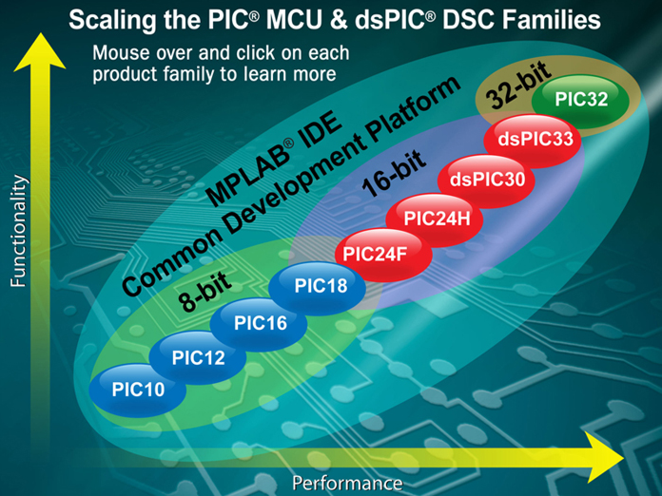
Figure 3. Microchip MCU portfolio classified by functionality and performance.
Microchip offers a complete portfolio for the developer with more than 325 models of different 8-bit microcontroller, which is mainly divided into three families. The company policy is to try to provide a device that meets the specific requirements of each project. Microchip offers an online tool that allows you to specify the requirements for an application in terms of memory, performance, power consumption and peripherals required and automatically selects the model that best fits your needs. It is the "Microcontroller Product Selector (MPS)."
(http://www.microchip.com/productselector/MCUProductSelector.html)

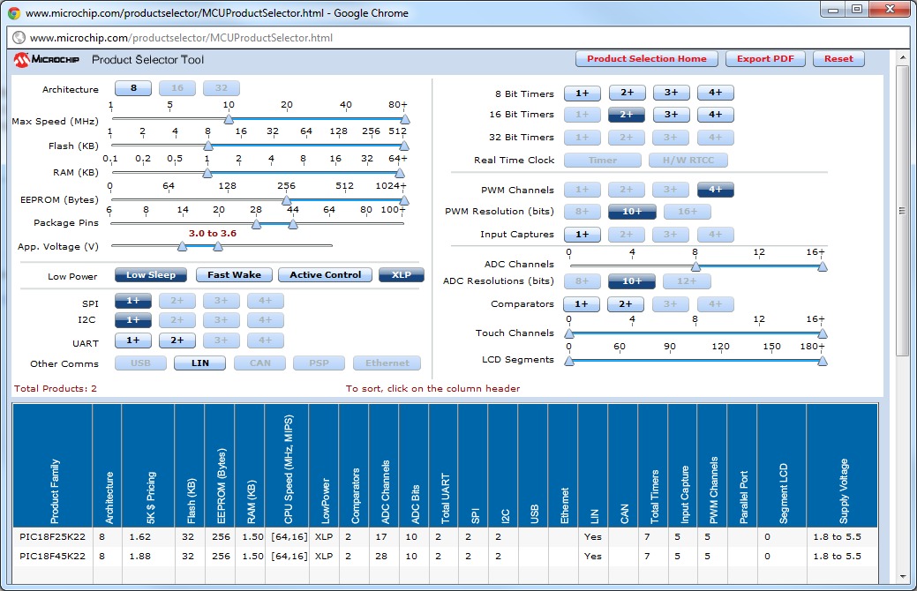
Figure 4. Microchip "Microcontroller Product Selector".
The 8-bit PIC MCUs offered by Microchip are classified into three families are described below:

Low-end - Baseline (PIC10MCU and PIC12MCU)
This family allows you to perform simple processes where the microcontroller is responsible for automatic control of one or more actuators based on the capture of certain sensors. In other words, these devices allow the automation of simple systems. These microcontrollers are widely used in ambient intelligence environments. The devices are 6 and 8 pins with encapsulated very small, low cost, easy to program and with a small volume of port I / S, as well as program memory and data. The following table (Table 2) shows the main characteristics of these devices.
8-bit PIC MCU Baseline devices (10F/12F)
Package Pins | 6-8 (SOT23, SOIC & DFN packages)
Program Memory (Flash) | 512bytes to 2K bytes
Data Memory | Max of 128 bytes RAM and max of 256 bytes EEPROM
Internal Oscillators | 4/8Mhz
Integrated Peripherals | 10-bit ADC, Comparators, Input/Output Capture and PWM
Integrated Buses | USART, I2C and SPI
Table 2. Features of 8-bit MCU Baseline devices.

Midrange (PIC16MCU)
The mid-range PIC Microcontrollers are primarily used to develop applications that require simple peripherals such as serial ports, keyboard matrix or alphanumeric LCD screens. This family is the most widespread in the units sold, but these devices are gradually being replaced by high-end units. Table 3 shows the main features of Microchip's PIC midrange.
8-bit PIC MCU Midrange devices (16F)
Package Pins | 14-64 (DIP and QFN packages)
Program Memory (Flash) | Up to 14K words
Data Memory | Up to 384 bytes RAM and 256 bytes EEPROM
Frequency | Up to 20MHz
Integrated Peripherals | 10-bit ADC, Op Amp, Vref Comparators, SR Latch, Capture, Compare and PWM, Keeloq, Cap Sense and LCD Drive
Integrated Buses | USART, SPI, I2C and USB
Table 3. Features of 8-bit MCU Midrange devices.

High-end (PIC18MCU)
These devices offer higher performance and connectivity capabilities. It is the gamily with largest number of devices in the catalog. It includes ultra low power devices, designed to maximize battery life. They include "Peripherals pin select" which allows to reconfigure the pin of the integrated circuit that is offered by a given peripheral.
8-bit PIC MCU Midrange devices (16F)
Package Pins | 18-100
Program Memory (Flash) | Currently up to 128K bytes (Architecture supports 2Mbytes)
Data Memory | Up to 4 Kbytes RAM and 1 Kbyte EEPROM
Frequency | Up to 40MHz (10-16MIPS)
Integrated Peripherals | All included in 16F devices plus 12-bit ADC, w Charge time measurement unit (CTMU), Integrated LCD Drivers and Enhanced PWM module.
Integrated Buses | USART, SPI, I2C, USB, CAN and Ethernet
Table 4. Features of 8-bit MCU Highrange devices.

Microchip hardware solutions
Microchip offers a number of hardware tools to help the developer to speed up their design. Depending on the complexity of each application, it provides a debugging solution with three different devices:
- The best tool for debugging Microchip MPLAB Real ICE. This is a high performance debugger in real time with unlimited ability to debug and monitoring real-time data. Its price is $ 499.
- The intermediate debugging solution is the MPLAB ICD3. This debugger provides limited debug access to the data memory in time. Its price is $ 219.
- Microchip also offers the PICKIT3, a tool capable of conducting real-time debugging at a cost of $ 79.
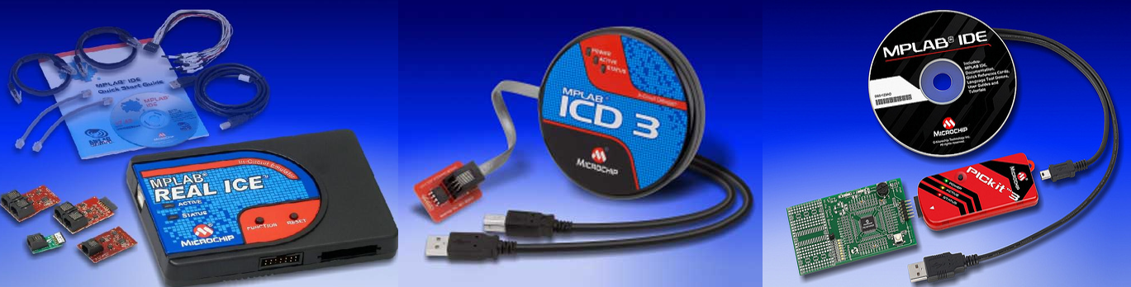
Figure 5. Microchip PIC Debuggers.

Microchip software solutions
Microchip offers the free MPLAB Integrated Development Environment (IDE) to all its customers. It is a highly recommended platform for developing all types of applications. It is compatible with Microsoft, MAC and Linux and supports third-party compilers, RTOS and tools and third-party hardware. It includes a software simulator for all models of Microcontrollers and is compatible with all debugging platforms discussed in the previous section. It is constantly updated to include new products and tools.
In the chapter devoted to experimentation, the main steps for implementing a project using this powerful software tool will be indicated.
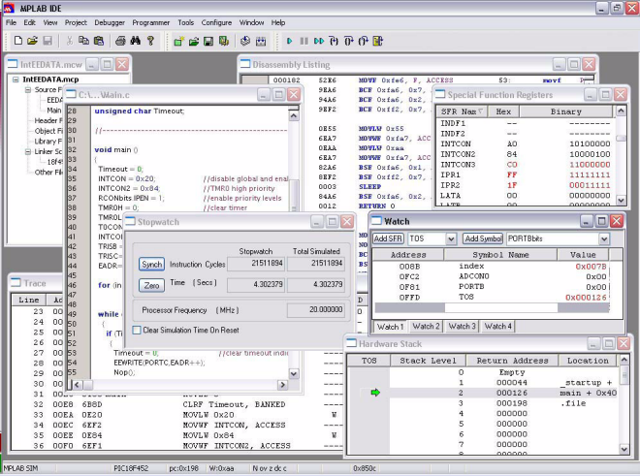
Figure 6. Snapshot of Microchip MPLAB IDE.

PIC18F basic architecture

Introduction
Although the family of high-end 8-bit PIC18F microcontrollers consists of more than 150 different models, they all share the same architecture. The key features of this architecture are:
- Harvard architecture: Two different memories for storing instructions and data with independent, non-shared, buses.
- RISC processor: Reduced Instruction Set. The execution of complex tasks is performed by combining the native instructions.
- Segmentation of instructions in two main steps, Search and implementing instruction.
- Specific purpose registers mapped in data memory.
The core architecture of PIC18F is shown in Figure 7.
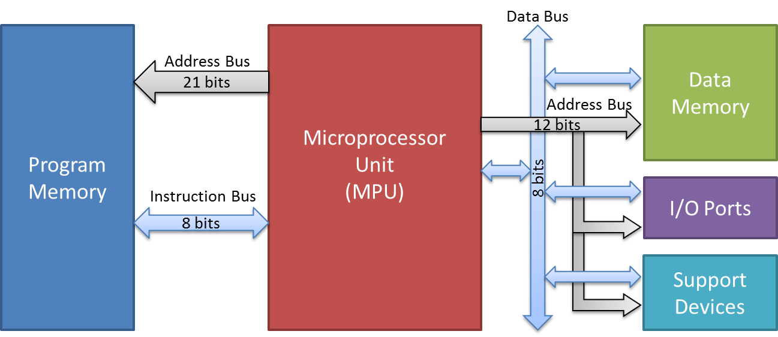
Figure 7. PIC18 Architecture.

As shown in Figure 7, Microchip's PIC 18F family has a Harvard architecture in which the program memory, intended primarily for program storage, and a completely independent data memory which implements the general purpose registers and on which are mapped to the various special purpose registers for the control of the microprocessor or peripheral devices.
The key features of the main blocks are shown below.

Main Processing Unit (MPU)
Its core parts are the following:
- Control Unit
- Arithmetic Logical Unit (ALU)
- Buses
- Registers

Control Unit
The control unit is responsible for managing the control lines that govern the various components of the microcontroller and the timing thereof.
Its implementation is carried out through a finite state automaton. It is capable of decoding the last instruction read from program memory stored in the instruction register (IR) and then sequentially activate the control lines leading to the execution of it.
Typically, the synchronization module of the microcontroller is usually located inside the control unit. There are multiple sources of oscillation which may be eligible to 18F PIC microcontroller. Although applications requiring high accuracy clock source require the inclusion in the design of an external oscillating source (quartz crystal or oscillator), microcontrollers PIC 18F family include an internal clock 8MHz that can facilitate and cheapen the final circuit in developments without high requirements regarding the accuracy of the clock. Depending on whether we use a quartz crystal, RC clock, an external oscillator or clock the microcontroller itself can have different sources of oscillation. The 18F family devices have two legs and OSC2 OSC1 through which we can connect external sources of oscillation. The 18F family foundation has 10 operating modes based on the source of oscillation:
LP: Consistent placement of a low-power external crystal. The frequency of the clock must be 32Khz.
XT: Quartz crystal or resonator with a frequency between 1MHz and 4MHz.
HS: Quartz crystal or resonator frequently than 4MHz to 25MHz and lower
HSPLL: quartz crystal resonator or external high speed with 4X PLL frequency multiplier enabled. The maximum supported frequency coincides with 40MHz, reachable only by connecting an external crystal or 10MHz oscillator with multiple activities.
RC: Watch RC (resistor-capacitor) device. In this way the paw through OSC2 is obtained in a consistent frequency provided by the RC divided by four (Fosc / 4.)
WICR: Watch RC (resistor-capacitor) device. Unlike as in the previous mode OSC2 paw microcontroller port is used as digital input / output.
INTIO1: Internal clock. In this way the paw OSC1 generates a frequency Fosc / 4 and the paw OSC2 functions as an additional digital port input / output.
INTIO2: Internal clock. In this mode both the paw paw OSC1 OSC2 as additional digital ports function as input / output.
EC: external oscillator. In this way the paw through OSC2 is obtained in a consistent frequency provided by the RC divided by four (Fosc / 4.)
ECIO: external oscillator. Unlike as in the previous mode OSC2 paw microcontroller port is used as digital input / output.
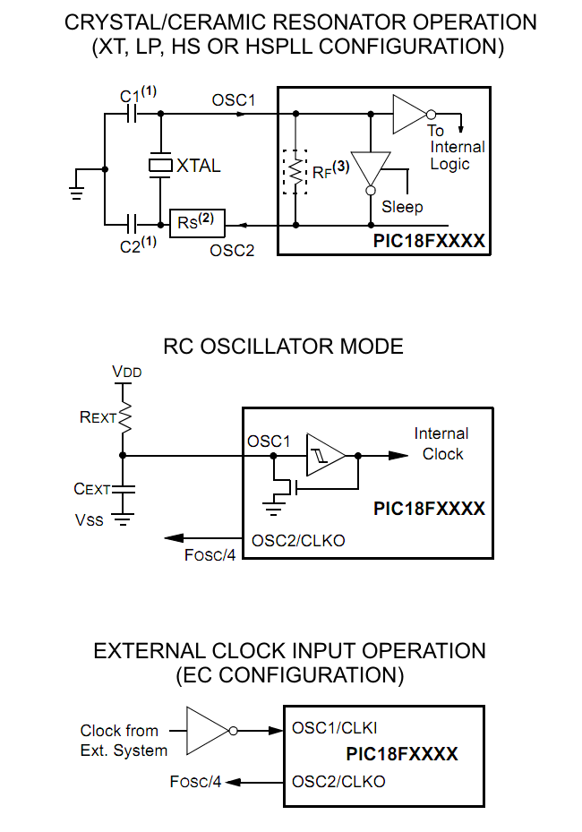
Figure 8. Oscillator modes.

Arithmetic Logical Unit
This unit is responsible for carrying out arithmetic and logical operations. Being a RISC processor, it does not include complex operators. The main operations supported by the arithmetic logic unit of the 18 family devices are shown in Table 5.
Arithmetic  Addition  Substraction  Increment  Decrement | Logical  And  Or  Not  Xor  2’s complement | Bit Manipulation  Bit set  Bit clear  Bit togle  Rotate left  Rotate right
Table 5. Arithmetic Logic Instructions.
Las operaciones que requieren dos operadores se llevan a cabo entre el registro de trabajo W y el valor volcado al bus de datos desde el banco de registros. El resultado de esta operación puede almacenarse en el propio registro de trabajo o en el registro direccionado por la instrucción.
Any function that requires two operators are carried out between the working register W dump and the value placed to the data bus from the register file. The result of this operation can be stored in its own work register or on the register directed by the instruction.
Example:
addwf 25,t This operation performs the sum of the contents of the register in address 25 of the regiser bank to the value of the working register, leaving the result in the very register 25 (t = 1) or in the work register (t = 0).
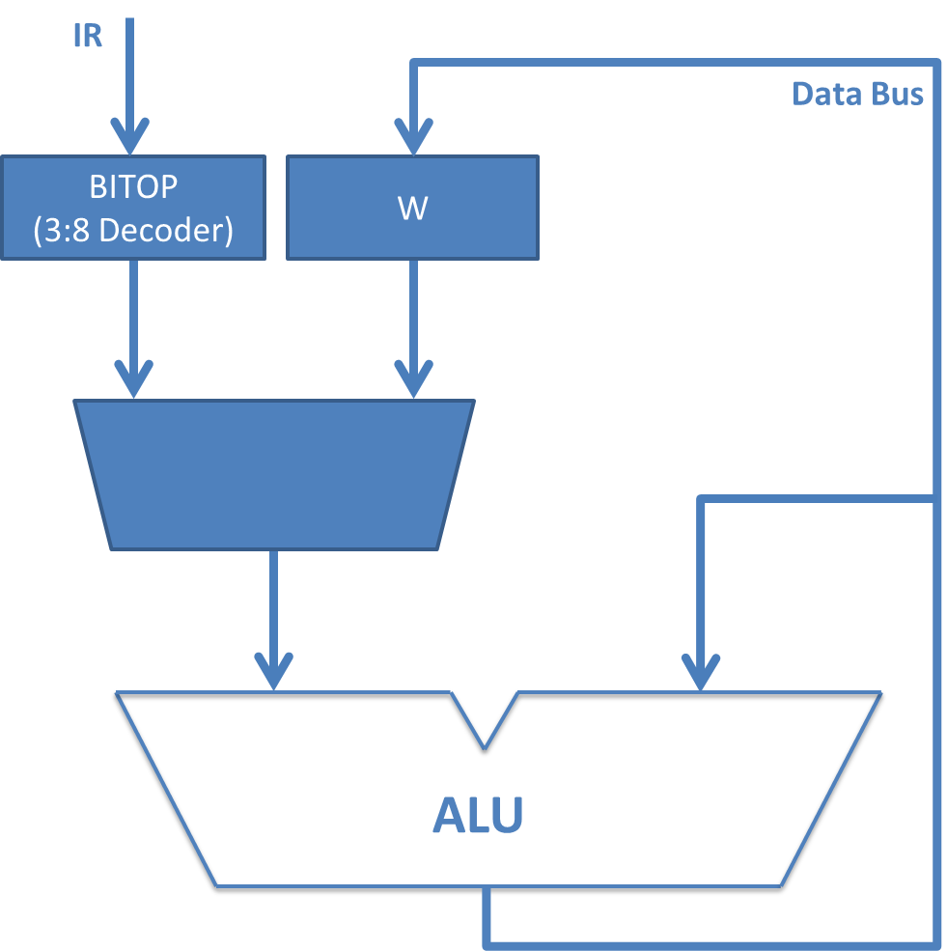
Figure 9. Arithmetic Logic Unit.

The bit manipulation operations are carried out thanks to BITOP. This operator is a 3:8 decoder for selecting the bit of the record on which it will perform a bit manipulation operation indicated in the instruction through a 3-bit operation.
Example:
bsf 25,b This operation activates the bit indicated by the operator “b” of the register placed in address 25 of the register bank. This operand occupies 3 bits allowing the addressing of the 8-bit register.
In addition to the arithmetic logic unit, the family 18 has an independent arithmetic multiplier that allows to carry out the product from any register bank records and the accumulator. The result of the multiplication of 16 bits is stored in the special-purpose register pair PRODH: Prodl.

Buses
The PIC microcontrollers family 18, having the Harvard architecture, contain two independent memories for data and instructions. Although it is a fact that this architecture provides higher performance, at least in 8-bit microcontrollers with relatively small memories, its use complicates the architecture by adding additional buses.
In addition to the control bus, operated by the control unit, the central processing unit runs four buses that allow to exchange information with the instruction memory, data memory, the ports of I / O and peripherals included in the microcontroller:
- Instruction memory address bus. It allows to address a particular instruction. Although pure Harvard architecture requires that the program memory is used only to store the instructions of the microcontroller firmware, Microchip can use this non-volatile memory space for storing data.
- Instruction bus. It allows bidirectional access, reading and writing information stored in program memory. The fact that the program itself has the ability to modify the contents of program memory, not only can use this space to store data, but the microcontroller provides the ability to self-reprogrammed. This capability is critical for developing such programs as bootloaders.
- Data memory address bus. It lets address a register in the register bank. In the register bank, general purpose registers are not only mapped but also the specific purpose registers needed to establish the configuration of the microcontroller and peripheral integrated access. This address bus marks the architecture possible directions to be discussed later.
- Data bus. This is a single data bus used for exchanging data between the central processing unit, memory and peripherals including data on the device.
The detailed description of the buses will be discussed later in the chapter about memories in the family.

Registers
In addition to the general purpose registers, the family 18 architecture includes certain special-purpose registers located in the MPU. The main ones are shown below. All records except the work register are mapped in data memory for easy access. Below are key records.
Working register (W). Intermediate register which allows to store special temporal information without collapsing the data bus.
Status register. It registers certain conditions produced in the last instruction. Not all instructions manipulate the status register, being mainly the arithmetic and logical operations the ones that have such capability. It represents certain conditions that have occurred in the last statement. Not all instructions manipulate the status register, being mainly arithmetic and logical operations the ones having such capability. The bits of this register indicate the following information.

N (bit 5): The last instruction has generated a negative result
OV (bit 4): The last instruction has generated an overflow
Z (bit 3): The last instruction’s result has been 0. Some transfer instructions have the capability to manipulate the Z bit indicating whether the transferred value is null.
DC (bit 5): In the last instruction (add or subtract) a carriage error has been produced in the 4th bit. It is important when we work with BCD magnitudes or of 4 bits.
C (bit 5): In the last instruction (add or subtract) a carriage error has been produced in the 8th Bit.
Program Counter. It addresses to the following instruction to be executed in the program memory. It will be studied in detail when we explore the program memory.

Data memory
The data memory, of RAM type, allows to store all the variable information required by a program. The address bus of 12 bits, can address up to 4096 positions shared by the general purpose registers and special-purpose registers. The latter are the last 128 positions of the memory map. Depending on the model, and peripherals included in it, there are unused positions. Therefore the data memory of a family PIC 18 can have a maximum of 3968 (3.9K) general purpose registers in the register file. Although the address is shared among all family models, many models make up less than one addressable memory. Figure 10 shows the memory organization of data for PIC18F4550 model to be used in the remote lab we will use in this course.
There are four addressing modes supported by the architecture of the family 18 PIC microcontroller.
- Direct addressing.
- Direct addressing via the BSR register.
- Direct through the bank of record.
- Indirect Addressing.

Pure Direct Addressing
The direct addressing method consists on indicating the specific address of memory locations to which an instruction accesses. Only one instruction can directly address the data memory. This is the instruction "movff" whose purpose is to load a register with the contents of another. In this statement the two operators are the addresses of source and destination registers. The two complete addresses, each 12 bits, 24 bits added to which must be added for the operation code. So this instruction occupies in memory 4 bytes (32 bits). With the exception of 4 instructions, which, as already presented occupy 32 bits, the instructions in the PIC microcontroller family 18 occupy 16 bits.
Example:
movff 0x125,0x0F3 This instruction will move the contents of the register addressed 125hex position memory to the register data at position F3 of the same. The encoding machine code of this instruction would
“1100 0001 0010 0101 1111 0000 1111 0011”
The red bits represent the opcode, the address indicated in the blue and green source record the destination address.

Direct routing through the BSR register
Except for the instructions in the previous section (movff), other direct addressing instructions occupy 16 bits. These instructions indicate the 6-bit opcode, 1 bit if the result of the execution of the instruction must be stored in the row direction or in the working register W and 1 bit more if accessed through bank record or BSR registry. So we only have 8 bits to indicate the direction of the memory location to which data is accessed, when we know that to address a memory location of data require 12 bits. The solution adopted by Microchip is indicated in the instruction the least significant 8 bits of the address and complete the same with the contents of a specific purpose register called BSR (Bank Select Register). The BSR register contains 4 bits of the positions more weight routed through these instructions. In this way the program memory is divided into 16 banks of 256 (28) positions, the selection is done by recording BSR. The banking division in the program memory can be seen in Figure 10. The BSR register is a record more specific purpose, which is mapped into data memory itself. To facilitate change the selected bank, the instruction set of the PIC18 instruction have movlb that loads the BSR record indicated in the same literal.
Example:
movlb 0x05
addwf 0xF3, 0, 1 This instruction adds the contents of the register addresses the work record. The full register your address with 4 bits of BSR register more weight that is loaded at the above address with the immediate value "5". Thus, the record addressed through the BSR is the 5F3hex. The last two operands indicate first that the value of the sum will turn over the job log (0 W, 1 the register) and second, that the direction indicated by the first operand is completed by the BSR.

Direct addressing through the access bank
Sometimes, working with memory locations of data located in different banks is particularly uncomfortable. Having to continually alter the BSR registry value, subtraction performance and hinders the development and maintenance of the project. Fundamentally, access to records of specific purpose for the use of an integrated edge, which are mapped in the second half of the last bank (the last 128 memory locations), requires continuous run instructions "movlb." The PIC microcontroller family 18 includes a solution that solves this problem: "The bank access." The bank access allows users to access a block of memory mapped registers of data without using the BSR register. This register block is formed by the first 128 records (bank 0) and the last 128 memory registers (bank 15), that match the specific records. It is very convenient to store the information required by a program in Access bank to avoid having to specify the specific bank in which it is located.
Access bank access to positions in the ranges 000Hex routed to 07FHex and F80Hex to FFFHex. When the 8 least significant bits indicate one direction between 00 and 7F to bank 0 is accessed as an address specified between 80 and FF 15, which includes bank records purpose. Access bank is shown in Figure 10.
All direct addressing instructions, except for the aforementioned "movff" have a bit operand is provided to indicate when the memory location indicated by the 8 least significant bits must be accessed through the BSR register or bank access. So the next instruction, used in the previous section above has a meaning in the following example.
Example:
movlb 0x05
addwf 0xF3, 0, 0 On this occasion, the last operand ('0 '), indicates that you must enter the address using the access bank. So the W register is loaded with the sum of its own value in the register addressed in the "FFR Hex".Direccionamiento Indirecto
The 18 family microcontrollers from Microchip have three records that allow access to memory locations without stating explicitly address them. These records "File Select Register" (FSR) function as pointers to the addresses to read or write. Fundamental to the implementation of data structures such as tables or arrays. Each FSR contains the address of a memory location. Like all records of a family microcontroller 18 stores 8 bits to store an address (12 bits) is necessary to use a couple of records FSR # H: FSR # L, where the character '#' to select between the three records FSR0 selection, and FSR2 FSR1. Access to information contained in the FSR register operands is accomplished by using indirect records (special-purpose registers INDF #), one for each FSR, which allow you to change the pointer value and even with autoincrement capability (using records POSTINC #) after each access.
Table 6 shows how to perform the checksum of the vector between the positions and 01fHex 000Hex using indirect addressing. Each time you access the log POSTINC0 accessing the information pointed to by a couple of records and once accessed FSR0 are increased.
clrf FSR0H ;reset FSR0 pointing 0x000
clrf FSR0L ; through access bank
clrf 0x05 ;reset file 0x005 through access bank (Counter)
loop movf POSTINC0, W ;move value of FSR0 to Work Register
; and then increment FSR0 to point next value
addwf 0x05,F ;add W to counter
movlw 0x19 ;load literal “0x19” in W (last position of Vector)
cpfsgt FSR0L ;if FSR0 > 0x019 skip next instruction
bra loop ;repeat until last position
movf 0x05,W ;load CheckSum in Work Register

Table 6. Indirect access to data memory.

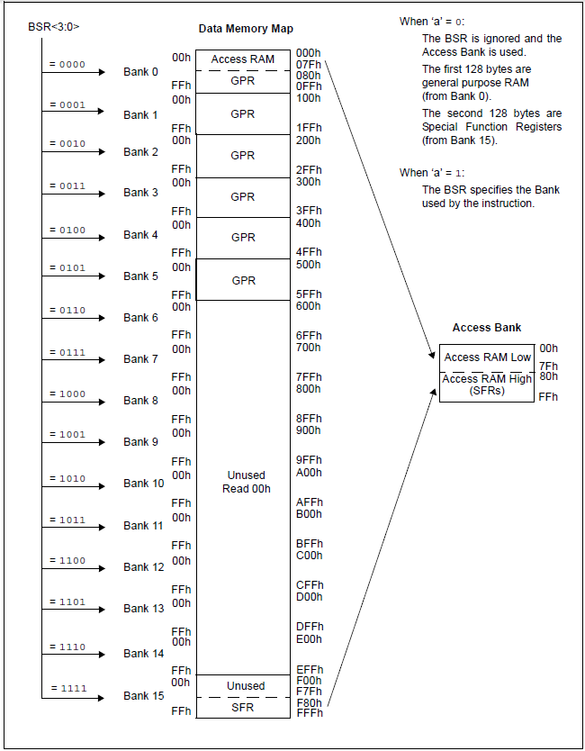
Figure 10. Data Memory Organization.

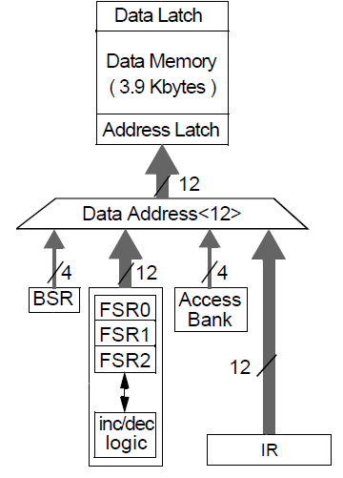
Figure 11. Data Memory Address Bus.

Program Memory
The program memory of PIC microcontroller family 18 is available in FLASH technology for development and OTP (One Time Programmable) for production. The technology used by Microchip FLASH memory supports up to 100K records. All 18 family devices have an address bus for program memory of 21 bits. Each memory location contains a byte, or can address 2 Megabytes which is the same 1 Megaword (or megainstrucción) taking into account that each instruction occupies 2 bytes. The instructions should always start in a couple of memory position because the PC has only 20 bits. When the PC directs the program memory, less weight line of the address bus is connected directly to "0".
As indicated above, the program memory is not only used for storage of firmware, but allows the storage and access of data from the program itself (only FLASH versions). The data access from program memory is carried out by special-purpose registers. TBLPTRU Records: TBLPTRH: TBLPTRL store a 21-bit pointer to program memory (the three most compelling bits of TBLPTRU are not implemented). The processes of reading and writing to the pointer stored in TBLPTR records are held by TBLRD instructions, reading and TBLWT, writing on the registration of special purpose "Tablate." These instructions allow post-increment, pre-increment and post-decrement. The code included in Table 7 shows how to carry reading 0x13FA0 position of program memory.
movlw 0x01 ;
movwf TBLPTRU ;TBLPTRU := 1
movlw 0x3F ;
movwf TBLPTRH ;TBLPTRH := 0x3F
movlw 0xA0 ;
movwf TBLPTRL ;TBLPTRL := 0xA0 - - > TBLPTR=0x13FA0
TBLRD ;TABLAT < - - (TBLPTR)
movf TABLAT,W ;load value of addr. 0x13FA0 in Work Register

Table 7. Accessing data in Program Memory.
Although the architecture of the PIC microcontroller family 18 2Mbytes lets you route, currently the model most built-in memory microcontroller that includes (PIC18F97J60) has only 256Kbytes. The distribution of program memory PIC18F4550 microcontroller, a device used for the experiment is shown in Figure 12.
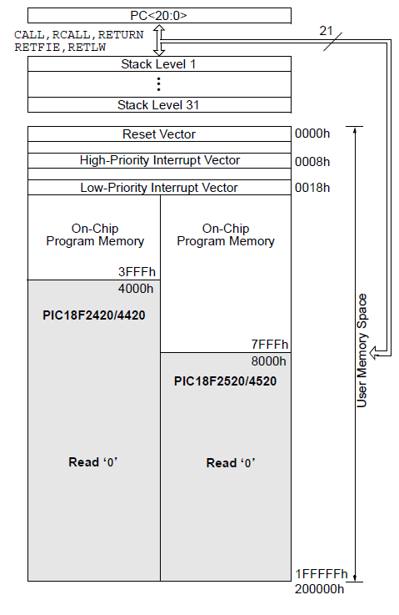
Figure 12. PIC18F4550 Program Memory Organization.

The address bus of the memory of the program is shown in Figure 13. Observe the reader that the architecture includes a stack of 31 positions to support the call to subroutines.
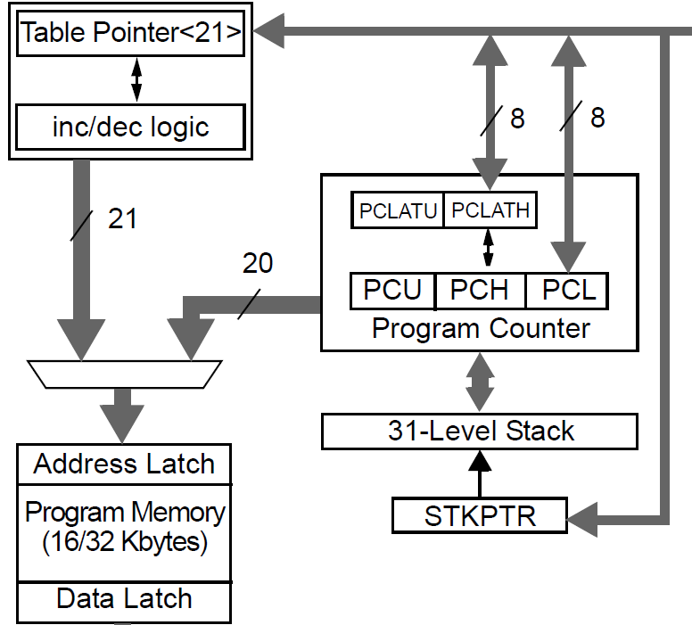
Figure 13. Program Memory Address Bus.

Additional resources
The PIC microcontroller family 18, all models includes a number of additional resources. The main ones are listed below:
Power-up Timer: On delay timer milliseconds PIC boot after causing a reset or after power to the device. This delay can stabilize both the clock frequency as the voltage before program execution
Watchdog Timer: This is a 16-bit timer overflow which may lead to Reset the device. This resource is used to avoid situations in which the microcontroller can be lost in an infinite loop software or hardware failures. When this resource enables the programmer to reset the counter with the statement "CLRWDT" before the timer overflows.
Brown-out Reset: This feature allows you to freeze the microcontroller in reset state when the supply voltage drops below a minimum. This will prevent the device to perform tasks specific situations erratic affecting the power supply
Fail-Safe Clock Monitor: This feature allows the microcontroller to continue executing the program if the external oscillator failure by automatically switching the device clock to the internal oscillator. By default, this feature is disabled.
The configuration of these resources is done by configuration word as discussed in the chapters devoted to experimentation.

Integrated peripherals
Being a family of next-generation microcontrollers, there are models that include integrated peripherals and advanced communication capabilities. The resources included in the 18 family devices are shown in Table 8.
- Digital Input/Output Ports
- Analog to Digital Converters
- Enhanced Universal Synchronous Asynchronous Receiver Transmitter (EUSART)
- Enhanced Capture/Compare/PWM Modules (ECCP)
- Comparators
- LCD Drivers
- EEPROM Memory
- Master Synchronous Serial Port (I²C, SPI)
- USB 2.0
- CAN
- Ethernet

Table 8. PIC18 family peripherals list.

PIC18F4550
The microcontroller model to be used in the remote laboratory is the PIC18F4550. This is a general purpose model. Its key features are shown in Table 9.
Features | PIC18F4550
Operating Frequency | DC – 48 MHz
Program Memory (Bytes) | 32768
Program Memory (Instructions) | 16384
Data Memory (Bytes) | 2048
Data EEPROM Memory (Bytes)º | 256
Interrupt Sources | 20
I/O Ports | Ports A, B, C, D, E
Timers | 4
Capture/Compare/PWM Modules | 1
Enhanced Capture/Compare/PWM Modules | 1
Serial Communications | MSSP, Enhanced USART, USB
Parallel Communications (PSP) | Yes
10-Bit Analog-to-Digital Module | 13 Input Channels
Comparators | 2
Resets (and Delays) | POR, BOR, RESET Instruction, Stack Full, Stack Underflow (PWRT, OST), MCLR (optional), WDT
Programmable High/Low-Voltage Detect | Yes
Programmable Brown-out Reset | Yes
Instruction Set | 75 Instructions; 83 with Extended Instruction Set Enabled
Packages | 40-Pin PDIP, 44-Pin QFN, 44-Pin TQFP
Table 9. PIC18F4550 device features.

Assembler for PIC18

Introduction
The assembly language or assembler is a programming language for low-level computers, microprocessors, microcontrollers and other programmable integrated circuits. It implements a symbolic representation of the binary machine codes and other constants needed to program a given CPU architecture and is the most direct representation of the specific machine code for each architecture readable by a programmer. This representation is usually defined by the hardware manufacturer, and is based on the mnemonic symbolizing the processing steps (instructions), processor registers, memory locations, and other language features. [WIKIPEDIA]
Although high-level programming of a micro does not need to know its architecture, the low level programming involves knowing the specific hardware device features. It is therefore important to master the concepts expressed in the previous section.
Since these devices are RISC, the instruction set is small and easily understandable. Despite this the family 18 has 75 native instructions (not counting the extended mode), compared with 35 included in the instruction set of its predecessors, the 16 family devices. This time the increase in the number of instructions makes programming easier by allowing conditional and repetitive structures in a simpler way. However, all the game instructions in the PIC16 instruction have been adopted by the family 18 to facilitate the adaptability of the new devices to older designs. Many family 18 devices, agree in the pin diagram with more or less obsolete devices of the family 16, thus facilitating the production and maintenance of old projects. So by replacing a PIC16F877 by a PIC18F4550, as we will use in the remote laboratory, does not imply to alter neither the source program nor the original PCB.

Instruction types
The instruction set of the PIC18 family mainly includes four types of instructions:
- Byte-oriented instructions
- Bit-oriented instructions
- Direct addressing instructions
- Control instructions

Byte-oriented instructions
As mentiones in the previous chapter, this category covers all the instructions with direct addressing: pure direct addressing, BSR register mediated direct addressing and access bank mediated direct addressing.
Except the instruction “movff”, earlier mentioned, the format of the instructions that conform this category is shown in Figure 14.
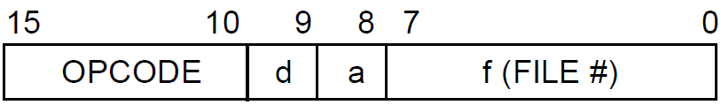
Figure 14. Byte oriented operations format.
The meaning nof each section is shown next:
OPCODE: The instructions in this format use 6 bits for operation code of the instructions. The control unit is based in this code in order to decode the instructions.
F(FILE#): As earlier mentioned, these 8 bits are used to address the data memory position (register) accessed by each instruction. This format allows to carry out two addressing operations:
- Through register BSR, this operand indicates the lower weight bits of the address, which is completed with the BSR 4 bits.
- Through the access bank to access the 128 first or last memory positions.
d: This 1 bit operand allows to set the target of an instruction:
- d=0 the instruction result is stored in the working register W.
- d=1 the instruction result is stored in the memory position addressed by the instruction. This is de default option.
a: This operand allows to select the instruction addressing mode:
- a=0 addressing through the access bank. Default option.
- a=1 addressing through the BSR register.
The assembler syntax is the following:
Cod_Operation Reg_Addr, d, a
Example:
andwf 0xF3, 1, 0 The instruction carries out the AND logical operation between the working register w and the contents of the register 0x018 in the data memory (a=0) and it stores the result in the register 0x018 (d=0).
The set of instructions in this category are shown in Table 10.
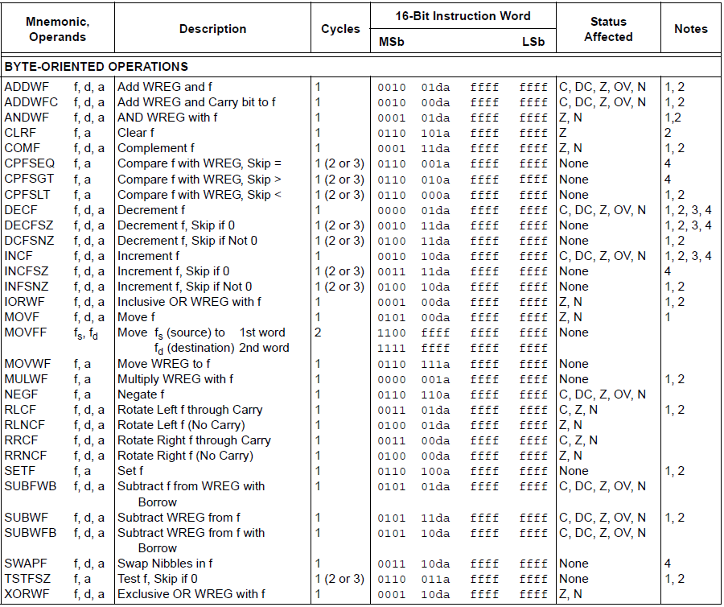
Table 10. Byte oriented instruction set.
As shown in Table 10, most of the instructions in this category include two operands, a data memory position and the working register W. They are all the instructions finishing with the characters “WF”. The instruction execution result can be stored in memory or in register W, through the operand d.

Bit-oriented instructions
They allow to alter the last bit of a memory position. The result of executing an instruction is stored in the very addressed memory position. The format of these instructions is shown in Figure 15.

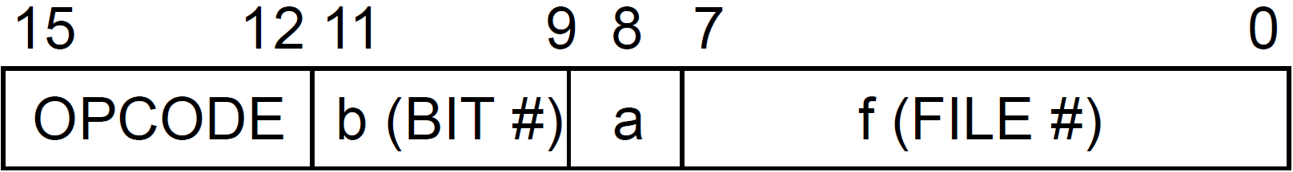
Figure 15. Bit oriented operations format.
The meaning of each section is shown below:
OPCODE: The instructions of this format use 4 bits for the operation code.
f(FILE#): As previously mentioned, these 8 bits serve to address the data memory position (register) accesed by the instruction. This format allows to carry out two types of addressing, bearing in mind the value introduced by operand a
a: This operand allows to select the instruction addressing mode:
- a=0 addressing through the bank access. Default option.
- a=1 addressing through BSR register.
b(BIT#): This operand indicates the bit affected by the instruction. It occupies 3 bits that allow to differentiate the register 8 bits (0-7).
The assembler syntax is the following:
Cod_Operation Reg_Addr, b, a
Example:
bsf 0x33, 3, 0 This instruction activates (sets to 1) the 3 bit (weight 8) of the memory address 0x033. The 0 value of the last operand indicates that the data memory addressing is carried out through the access bank.
The set of instructions encountered in this category are indicated in Table 11.
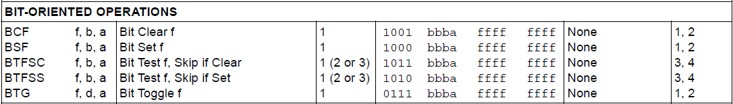
Table 11. Byte oriented instruction set.
Within the bit-oriented operations, there are two instructions that allow to implement the conditional structures and thus to take decisions. The instructions “btfsc” and “btfss”, which in the family 16 PIC were the only way to include conditional structures, allow to test a register bit and jump to the next instruction in case that such bit is active (btfss) or inactive (btfsc).
Example:

movlw .10 ;load decimal value “10” in W reg.
subwf counter,W ;Subtracts W from Counter saving result in W
btfss STATUS,Z ; Test Z flag Skip next operation if Z is set
bra counter_no_10 ; this operation is only executed if last subtract differs 0
bra counter_si_10 ; this op is executed when counter equals to 0

Inmediate addressing instructions
The instructions with this type of addressing include one single literal operand. Being an 8 bit microcontroller family, the immediate operand occupies 1 byte which will serve as instruction operand. The instruction format is shown in Figure 16.
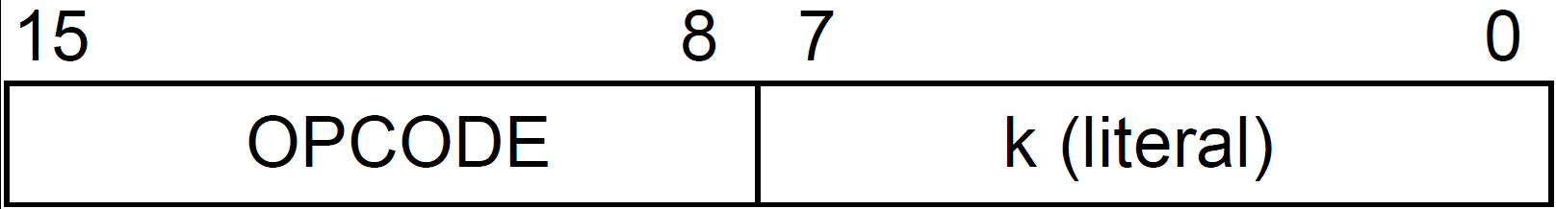
Figure 16. Literal operations format.
As shown in Table 12, these commands carry out an operand between the very inmediate operand and the value stored in the working register, stored the result in the latter one.
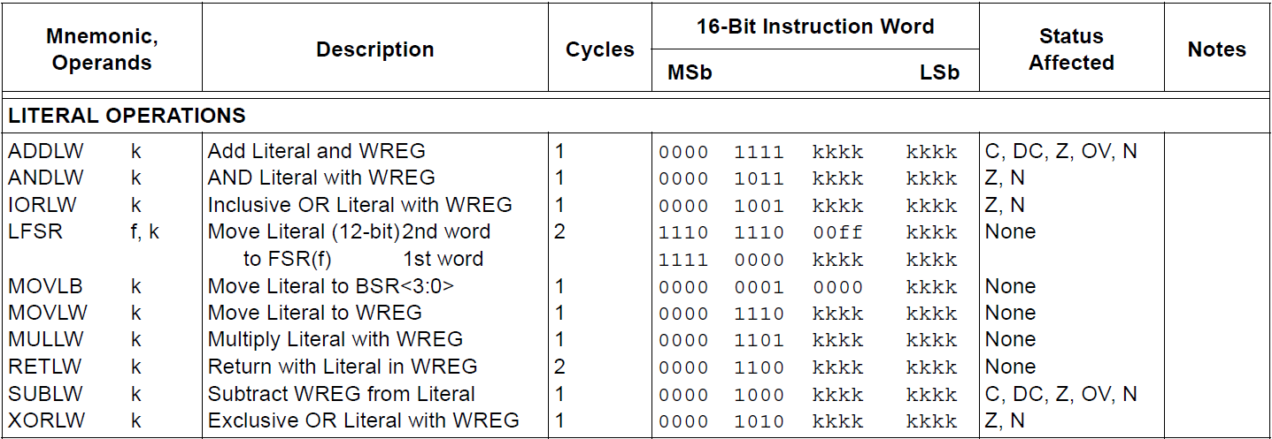
Table 12. Literal operations instruction set.
The assembler syntax is the following:
Cod_Operation literal_value
Example:
sublw 0x33 Esta instrucción resta el valor del registro de trabajo W al valor inmediato “0x33” almacenando el resultado en el propio registro de trabajo.
Within the instructions with immediate addressing there are two of specific purpose which should be explained separately:
movlb: it loads the value of the immediate operand in register BSR. Its function is to ease the selection in the access to the different data memory banks.
lfsr: This instruction differs in format to the rest since the immediate operand occupies 12 bits necessary to wholy address a data memory position. Its function is to load the immediate value in the register pair FSR identified by a second operand. Example:
lfsr 0x234,1 it makes the register pair FSR2 to load with the value 0x234. Thus, the value of register FSR2H will be 0x2 and the register FSR2L will pass to have the value 0x34. This instruction eases the usage of immediate addressing in family 19 PICs.

Control instructions
goto The “goto” instruction occupies 32 bits in the program memory, it receives as operand the complete address where the next instruction to execute is encountered: the jump instruction. Having into account that the address bus within program memory occupies 21 bits, but the instructions necessary have to start in an even address (least significant bit “0”) the operand of this command occupies 20 bits. This command will allow to jump to any position in the program memory, but it takes twice the execution time, making the overall performance of the microcontroller to be reduced if executed subsequently.
Bra The instruction “bra” executes a relative jump. As operand, instead of receiving the memory address to jump to, it receives an immediate 12 bit register expresed in pure binary signed and 2 complemented which represents the number of instructions (of 16 bits) that it has to skip (positive forwardly, negative backwardly) with regards to the current position in the program (Program Counter). This instruction takes 16 bits in memory, but in contrast to a goto, it does not allow to jump to any position in the program memory, but only to labels encountered in a maximum distance of 2048 (2¹¹) positions with regards to the instruction that provoked the jump. This range is effective in the majority of the jumps required by the control structure, which represents 90% of jumps in an assembler program.
As will be seen later in the experimentation chapter, whenever developing a program in assembler, it is not necessary to directly indicate the value of the goto or bra operands, but we express such values using labels which are interpreted by the asembler program.
The 18 family includes, see Table 13, a set of additional jumping instructions, which work conditioned by the value of the different bits of the status register (STATUS). For example, the “BC” instruction is similar in format to instruction “BRA” but it only executes the jump if when executing the Carry flag value (C) is 1. The instruction “BNC”, on the other hand, only executes the jump when Carry is 0.
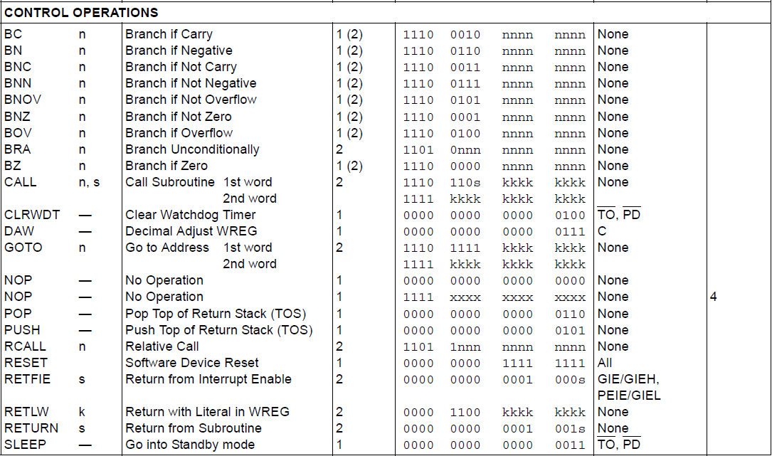
Table 13. Control operations instruction set.
As can be observed when the studying the PIC18 microcontroller architecture, there is a hardware stack of 31 positions that aims to allow subroutine treatment. The structure of this stack is LIFO, returning when reading its latest written value over it.
A subroutine is a code block which carries out a task requested at different points in a program. The main program can call the subroutine execution from different points, taking back the control after its execution from the very point where the call or jump to the subroutine took place. There are two instructions which allow to jump to the execution of a subroutine and another two that returned control to the calling source point:
Call The function of this instruction is simillar to the one executed by instruction “Goto” but with a main difference: it stores in the stack the return address (the next one to the address where Call is found). As that one, it takes 32 bits and receives the complete address where the first instruction of the subroutine is encountered.
Rcall This instruction is similar to “BRA”, but it stores the return address.
Return It provokes the return to the last position stored in the stack.
Retlw With immediate addressing, it makes the return to the last position stored in the stack, storingn in the working registry the value indicated by means of the literal operand. Sometimes, the working register is the container employed for information Exchange among different program points.
Whilst using subroutines is dangerous to employ the instruction “RCALL” since occasionally is not known where the routine is physically encountered and, thus, the distance between this and the call. Whenever trying to execute a relative jump, either through the instruction “BRA” or with “RCALL”, an address which excedes the maximum distance of 2040 instrutions, the assembler program will show an error easing the correction from the programmer side.
Within this block, some purpose specific instructions have been placed. Next their functionality is described:
CLRWDT It resets the Watch dog timer, avoiding its overflow.
NOP Instruction that does not bring about any action. It can be used to lose time whilst executing a program.
SLEEP It activates the low consumption mode.
RESET It provoques a software reset that restarts the firmware.
PUSH It stores teh PC in the stack.
POP It stores teh last value stored in the stack in the PC, provoking the corresponding jump.

Data access instructions in program memory
These instructions, studied in the previous chapter, allow to read and write information in the data memory. The registers TBLPTRU-TBLPTRH-TBLPTRL act as pointers to the program memory; Reading and writing data is carried out through the TABLAT register. All the instructions of this block can be viewed in Table 14.
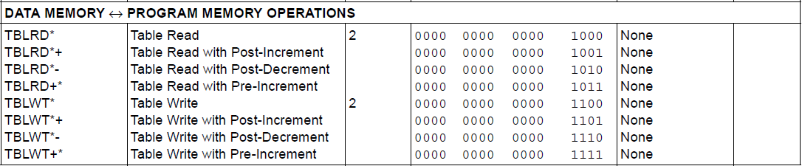
Table 14. Program memory operations instruction set.

Control structures
As earlier explained, to develop a project in an assembler language differs significantly from doing it in another high-level language. For those students who have experience programming in a high level it is key to understand how control structures are developed in assembler. Although the key to master low-level programming is based on the experience and utter knowledge of the MPU specific instruction set, the examples with control structures, conditionals and repetions, which are shown next should result useful for the programmer to domain the 18 PIC microcontroller family assembler.

Simple conditional structure
A simple conditional structure, or decision take, allows to carry out a process only when an specific condition is fulfilled. Such condition usually consists of a comparison between a register in the bank and another immediate one or in the working register W.
Figure 17. Simple conditional flowchart.

In high level languages, the conditional structures are usually implemented through the “IF” instruction. In the 18 family PIC microcontroller, the comparison instructions “CPFSEQ, CPFSGT and CPFSLT” provide an optimal tool to undertake these structures. These instructions compare the register in the bank specified by them, with the working register W and they jump to the following instruction in the case that the first one is equal, greater or less than the second respectively.
Example:
if (var1 == 10)
{
var1 = 0;
var2 = var2 + 1;
}
Through the code expressed before, in the case that the value of the variable “var1” was “10”, the variable “var1” will be reset to 0 and the variable var2 will be incremented. The coding of this structure in the 18 family PIC microcontroller assembler is shown next. Please note that in assembler there are no variables. They are directly accessed to the positions in the data memory (general purpose registers).
movlw .10 ;W is set to decimal 10
cpfseq reg1 ;Register 1 is compared with value W and whenever they are the same
;we jump to the following instruction
bra end_cond ;This instruction is only executed when reg1 is not 10
clrf reg1 ;We reset the value of register reg1
incf reg2 ;We increment the value of register reg2
end_cond ;The program continues even when the condition has not been fulfilled.
The reader should notice that when the condition is matched, the cpfseg instruction provokes that the next instruction is not executing, skipping to the next one. For this reason, in that instruction, only executed when the condition is not matched, a jump to the end of the conditional process will be placed.

Double conditional structure
This control structure allows to select between two processes upon a condition evaluation. Whenever the condition is matched a process is executed, otherwise the other process will be executed.
Figure 18. Double conditional flowchart.

The implementation of this structure in PIC18 assembler is similar to the one used to carry out simple conditional structures. In this case, however, though the instruction that is not matched a jump to a label where the process corresponding to the non-matched condition will be produced.
Example:
if (var1 > 10)
{
var1 = 0;
var2 = var2 + 1;
}
else
{
var1 = 100;
var2 = var2 – 1;
}
With the above example, expressed in a high level language, we check that depending on the value of variable “var1” two alternative processes are executed. Whenever the value of “var1” is greater tan 10, “var1” is set to 0 and the value of “var2” is increased. On the other hand, if the original value of “var1” is less than or equal to 10, the value 100 will be assigned variable “var1” and the value of “var2” will be decreased.
movlw .10 ;We set the value of W to 10 in decimal
cpfsgt reg1 ;We compare reg1 with the value of W
;if it is bigger we jump to the next instruction
bra noBigger ;This instruction only executes when reg1 is not bigger than 10
clrf reg1 ;We reset the value of of reg1
incf reg2 ;We increase the value of reg2
bra end_cond ;We jump to the end of the conditional structure
noBigger movlw .100 ;We store the decimal value 100 in the working register W
movwf reg1 ;We load into reg1 the value W
decf reg2 ;We decrease reg2
end_cond ;The program continues after the conditional structure

Multiple conditional structure
The multiple conditional structure allow to compare a variable against different values, executing for each analysed value an specific process.
Figure 19. Multiple conditional flowchart.

In the next example we can encounter the PIC18 assembler code for a multiple conditional structure. The concept is similar to the other conditional structures, using the instruction “CPFSEQ” to compare the value of a register with the possible immediate values analyzed.
Example:
switch (var1) {
case 1: var2 = var2 + 1;
break;
case 2: var2 = var2 – 1;
break;
case 3: var2 = var2 + 2;
break;
default: var2 = 0;
break;
}
The condition in assembler of this switch statement, used in C language, is shown next:
movlw .1 ;We set Wto value 1 in decimal
cpfseq reg1 ;We compare reg1 with the value W
;if they are the same we jump to the next instruction
bra no_1 ;If this value is not fulfilled, we try with the next one
incf reg2 ;We increase the value of reg2
;This is the process executed when reg1 is 1
bra end_cond;We jump to the end of the conditional structure
no_1 movlw .2 ;We set W to value 2 in decimal
cpfseq reg1 ;We compare reg1 to the contents of W,
;if they are the same we jump to the next instruction
bra no_2 ;if the previous value is not matched, we try with the following one
decf reg2 ;We decrease the value of reg2
;This is the process to execute when reg1 is 2
bra end_cond;We jump to the end of the conditional structure
no_2 movlw .3 ;We set W to 3 in decimal
cpfseq reg1 ;We compare reg1 with the value of W
;if they are equal we jump to the next instruction
bra default ; If the value is not matched, a default process is executed
movlw 2 ;We add 2 to reg2
addwf reg2 ;This is the process to execute when reg1 is 3
bra end_cond;We jump to the end of the conditional structure
default clrf reg2 ;We reset reg2 when no condition has been met
end_cond ;The program continues after the conditional structure.

Repetitive structure with undefined number of iterations
This structure allows to repeat the execution of a process an undefined number of iterations, taking into account the break condition. In this structure, the condition can be assessed at the beginning, making the iteration number go from 0 to N, or at the end, after the iterative process, making the process execute at least once.
For the implementation of this structure, we will use the same comparison instructions used for the conditional structures: CPFSEQ, CPFSGT y CPGSLT. These instructions “jump” an instruction whenever the register from the bank compared with the working register is equal, greater than or less than, respectively. That instruction “skipped” when the condition is given will be the one used to break the repetitive structure. Therefore, we must indicate the condition that will cause the loop exit and not the condition to remain in it.
Example:
do {
var1 = var1 + 1;
} until (var1 > 10)
In the previous example, coded in C, the repetitive process, consists on incrementing the variable “var1” which is repeated until the value of it is greater than 10. The coding of this structure in the PIC18 assembler will be something similar to the following:
loop incf reg1 ;The repetitive process is executed. We increment reg1
movlw .10 ;We load the working register with value 10 in decimal
cpfsgt reg1 ;If Reg1 is greater than 10, it will jump to the next instruction
bra loop_end ;if the break condition is fulfilled, we go out of the structure
bra loop ;on the contrary, we repeat a new iteration
loop_end
In the previous process, the condition is assessed after the execution of the repetitive process. This implies that it will be executed at least once. If the condition is assessed at the beginning we would have a structure where the iterative process cannot be executed when the break condition is matched from the beginning. The code would be the following:
loop movlw .10 ;We load the working register with value 10 in decimal
cpfsgt reg1 ;If Reg1 is greater than 10 we jump to the next instruction
bra end_loop ;If the break condition is matched we jump outside the structure
incf reg1 ;on the contrary, the repetitive process is executed
bra loop ;we go through a new iteration

Repetitive structure with predefined number of iterations
This structure allows to repeat a process execution a known number of iterations. The implementation of this structure requires using a counter that controls the number of times that the repetitive process is run.
The PIC18 microcontroller’s instruction set includes an instruction that eases the implementation of this structure: “DECFSZ”. This instruction decreases a register from the register bank and if the result of it is 0, it “jumps” to the next instruction.
Example:
for (i = 0; i < 10; i++)
{
var1 = var1 + 5;
}
The previous example represents the typical “for” structure in C. The i variable is set to 0, incrementing after each loop iteration until it reaches the break value, in this case set to 10. In this case, the repetitive process will carry out 10 iterations. Its implementation in assembler is indicated next. Instead of setting the counter to 0 and compare it with the number of iterations, in assembler we set it to the number of iterations and decrease it after each iteration through the decfsz instruction.
movlw .10
movwf regcont ; the counter register is set with the number of iterations
loop movlw .5 ; the repetetive process is executed
addwf reg1 ; in this case, it consists on adding 5 to reg1
decfsz regcont ; We decrease regcont and if regcont is 0, we jump to the next instruction
bra loop ; If the result of decreasing it is not 0, we undertake a new iteration
end_loop ; If the counter reaches 0, the iterations have reached to their end

Assembler directives
Each instruction in assembler language is coded as an instruction in machine code. However, the programmers need certain directives to indicate how the assembler program has to be introduced in the program memory. The main directives are indicated next:
List: This directive indicates to the assembler program the microcontroller model for which the program has been designed.
Example:
list p=PIC18F4550
Radix: This directive establishes the default numeric base. This is, the numeric base used whenever a value is given without specifying the base. Despite this directive, it is convenient to indicate when the hexadecimal base is used by pre-fixing “0x” to the value (e.g.: 0x1A), when the decimal base is used by prefixing a point (example: .18) and when binary base is used, by pre-fixing the “b” letter and indicating the code under double quotes (e.g: b’01100110’).
Example:
radix hex
This directive establishes that the values with undefined base are considered as having hexadecimal base.
Config: This directive allows the programmer to establish the values for the configuration word. In the chapter corresponding to the PIC18 microcontroller architecture the common features to all the devices in this family were studied. Resources such as the watchdog timer, the power on reset, the Brown out reset or the synchronization source have to be configured through the configuration word.
Example:
config WDT=OFF, OSC=XT, PBADEN=OFF
The previous directive establishes the configuration word so that the watchdog timer is disabled, the system clock connected to an external quarz crystal and port B configured, by default, as digital.
Org: This directive allows to indicate the position of the program memory where to store the code and data placed behind it.
Example:
Org 0x200
movlw 0xFF
This directive forces that the instruction “movlw 0xFF” will be introduced in position 200h of the memory program. The indicated instructions will be placed, next, in successive positions.
Equ: The equ directive allows to declare labels. It is important to remind that in assembler there are no variables or constants, the labels will be identifiers that will be replaced when assembling the program with its respective values.
Example:
counter equ 0x20
This directive generates the label “counter” assigning it the 20h value. Then, the assembler program will replace all coincidences of the “counter” identifier by their corresponding value “20h”. Thus, the instruction “movwf counter” that has direct addressing will dump the value of the working register W over the record 0x20 of the register bank.

Generic label definition file
Microchip provides a file for each device which includes the definition of labels corresponding to all the specific resources in each microcontroller. The use of these files is paramount since they do allow us to refer to specific purpose registers, and to the bits belonging to them, by their name, rather than through the position to which they are mapped.
These files must be included in the project by means of the directive #include at the beginning of the file which includes the main program.
For example:
#include “p18F4550.h” ;File defining labels for PIC18F4550
Thus, for instance, we will refer to the status register as STATUS instead of indicating the position it occupies, i.e. in the case of the PIC18F4550 is 0xFD8.

The WebLab-BOT lab

Introduction
The remote lab WebLab-BOT allows the user to undertake remote experimentation with PIC microcontrollers. Instead of providing the typical development environment based on printed board with standard peripherals: LED diodes, triggers, LCD screens, power meters and so on, this remote laboratory allows the user to develop a mobile robot firmware based on the PIC18F4550 firmware.
The experience accummulated by the people who developed this remote lab, used in their microcontroller related subjects, reflects the advantages of using microbotics for learning microcontroller programming. Microbotics increases student motivation since they feel more motivated upon experimentation and brings about an increase on the contents learned.
Microbotics is a modern technology, emerged only few years ago, that previsibly will be applied in a big portion of human activities in the XXI century. Microbots are small and smart mobile robots capable of undertaking rapidly and precisely many simple tasks. The microbot chosen by this lab, the “Azkar-Bot” robot comercialised by the company Microsistemas Programados S.L. is a didactic programmable robot, oriented towards hobbyists in general and medium and high engineering education, in particular.
The student has to “program” the mode in which the robot will behave. The sensors allow to detect the conditions of the robot, the engines provoke its movement and the PIC18F4550 microcontroller allows to control its operation through a program. A metaphor commonly used in microbotics is that engines are alike muscles, the sensors constitute the sensitive organs and the microcontroller is the brain that specifies its operation.
On the other hand, a microbot is a conventional software system where the sensors are inputs, the engines outputs and the microcontroller, the system in charge of executing a program that governs the behaviour of the system. For this reason, a student capable of programming a microbot is capable to face any system based on a microcontroller, independently of its nature.

WebLab-BOT remote lab architecture
In order to guarantee the physical robot usability, this experiment has been deployed under the WebLab-Deusto platform for remote lab integration. The WebLab-Deusto project provides a software infrastrucgture based on the web, independent of the lab and scalable which allow University of Deusto to offer diverse labs to the students through Internet.
The main server of the WebLab-Deusto project undertakes several management tasks such as authentication, queue management, or user tracking and provides scalability, flexibility and security for the experiment used in this educational module.
On the other hand, it is in charge of user to robot interaction tasks. A custom built lab server has been implemented also responsible of communicating with the robot. This software has been developed using C# through the .NET API provided by WebLab-Deusto, offering the framework to connect the experiment with the WebLab-Deusto main server. In order to avoid using cables, which impend robot movement, all the communication between the robot and the server is carried out through Bluetooth. Due to this, the lab server must be placed near the experiment “tatami”, so that the Bluetooth coverage between the robot and the server are guaranteed. The architecture of the WebLAb-Bot is shown in Figure 20.
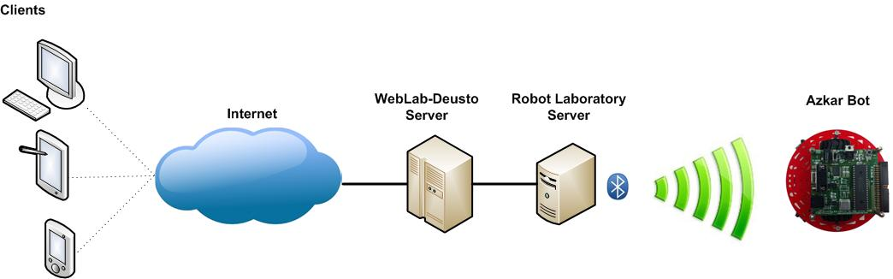
Figure 20. WebLab-Bot architecture.

Azkar-Bot robot design
The design of the robot was carried out aiming to develop a device that fulfills with the requirements of the experiment at a low cost in order to favour its deployment by different institutions and even to launch several instances of the experiment in the same organization with the purpose of reducing user waiting times.
The AzkarBot has been built over the basis of the low-cost comercial robot, named identically, developed by the company "Ingeniería de Microsistemas Programados, SL" (http://www.msebilbao.com ). This feature allows users to acquire a similar robot to test their programs at a reduced price.
Figure 21 shows the robot modular design used in this experiment. The main components are two identical boards based on the Microchip Technology Inc© PIC18F4550 microcontroller. One of the cards is responsible to control the communication with laboratory server (communication supervisor) whilst the other undertakes the actions that control the robot movement (experiment controller).
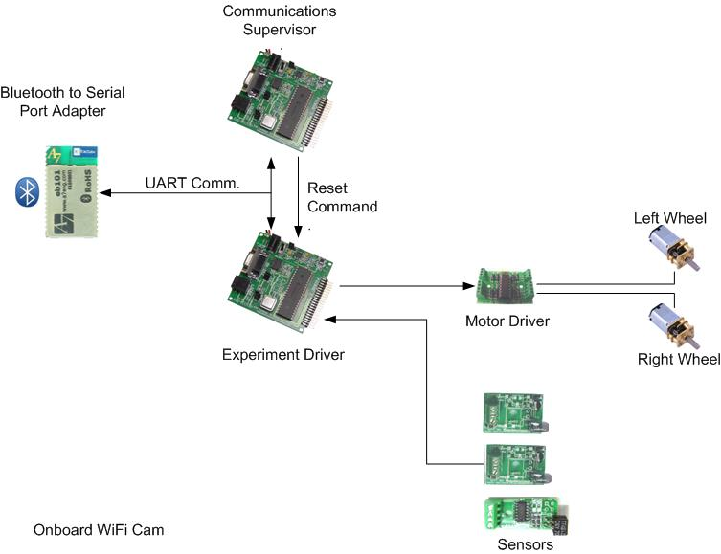
Figure 21. Modular design of robot Azkar-Bot used by WebLAb-Deusto.

The Communication Supervisor is in charge of controlling the time used by each user, together with the experiment evolution. On the other hand, the Experiment Controller is responsible of controlling the movement of the engines connected to the left and right wheels of the robot, and of reading and interpreting the sensors. The Azkar-bot used in the experiment has two infrared sensors to detect obstacle proximity on the left and right, and a CNY70 sensor to detect the surface colour over which the robot moves.
The microcontroller integrated in the Experiment Controller is programmed with a built-in bootloader which receives the firmware sent by the user, places it on the program memory and finally launches its execution. This bootloader is activated after a reset, generated by the Communication Supervisor, and allows to reprogram the microcontroller with the program sent from the lab server through a Bluetooth RFCOMM port.

Robot connection
For the robot programming, the student must first know the pecularieties of the used sensors and engines. Besides, they must know how to connect them with the integrated microcontroller with the “Controller Experiment”. During the experiment development, this microcontroller will be programmed with the student executable archive and will be in charge of controlling the robot movement. Figure 22 shows how the mobile robot engines and sensors used in the WebLab-Bot remote lab are connected.
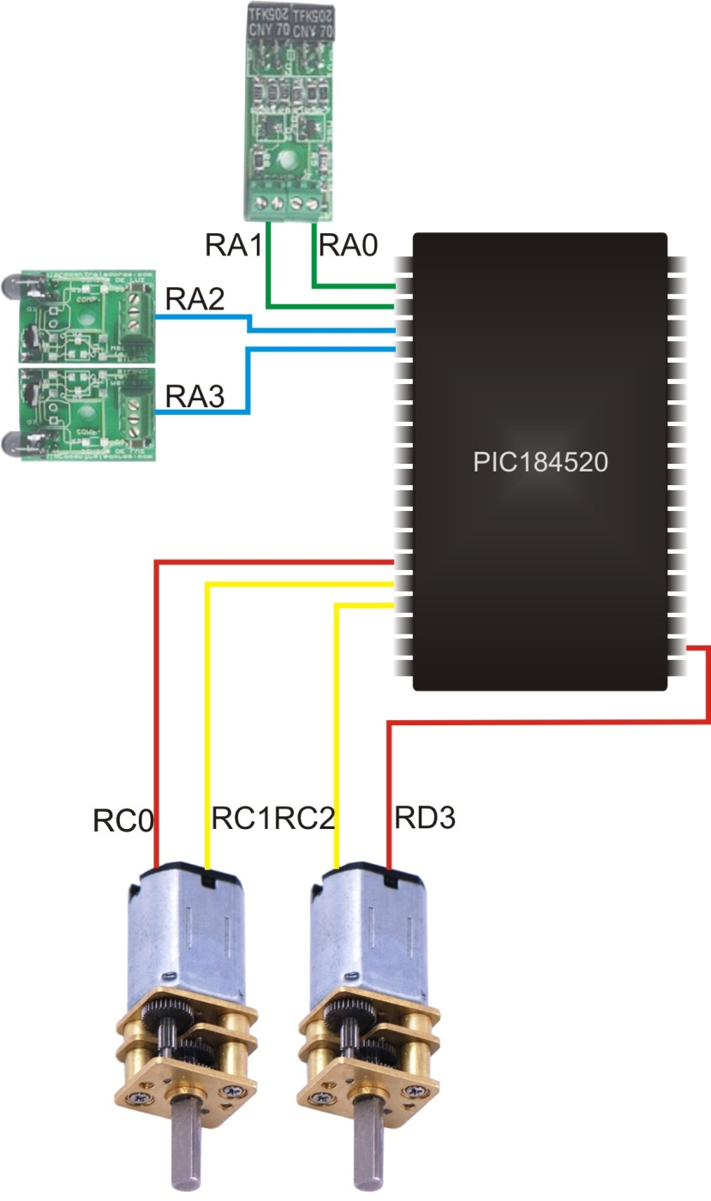
Figure 22. Connections of engines and sensors to the Experiment Control.

The engines
The movement of the AzkarBot mobile robot used in the WebLab-Bot remote lab is controlled through two engines directly assembled to the axle of the driving gear. Figure 23 shows the AzkarBot robot’s mobile platform. The engine use, belonging to the popular producer “Pololu Robotics & electronics”, offers a high fidelity and incuded a 150:1 reductor which acquires enough power to move the robot. It is the Pololu 997 module, similar to the popular 12mm Sanyo micro-engines. Its specifications are shown in Table 15.
150:1 Micro Metal Gear Motor HP Specifications
Size: | 24 x 10 x 12 mm
Weight: | 0.34 oz
Shaft diameter: | 3 mm
Gear ratio: | 150:1
Free-run speed @ 6V: | 200 rpm
Free-run current @ 6V: | 70 mA
Stall current @ 6V: | 1600 mA
Stall torque @ 6V: | 45 oz·in
Extended motor shaft?: | N
Table 15. Pololu 997 specifications.
The connecton of the PIC18F4550 microcontrollers integrated in the “Experiment Controller” has been carrid out through the MSE-A100 driver developed by the company “Ingeniería de Microsistemas Programados S.L.”. This general purpose driver is based on SGS-THOMSON’s L293B device. It consists of 4 amplifier channels totally integrated with each other. Each channel is capable of supporting output currents of 1 A with peaks up to 2 A. They have a high immunity to noise, protection against high temperatures and load feed tension separated from the logic feed tension.
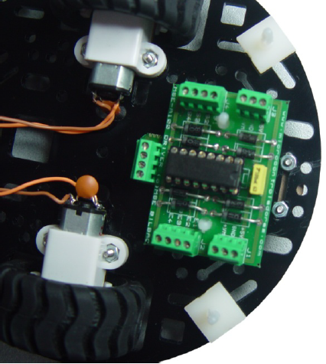
Figure 23. Engine connection through driver MSE-A100.

The left wheel engine is connected to pins RC1 and RC0 of port C, with C and D ports, respectively. Far from begin random, the engine connection has taken place bearing in mind the future use of modules CCP1 and CCP2 for modulating the pulse bandwidth, which allows to control with precision the rotation speed of both engines. These PWM modules are multiplexed to pins RC1 and RC2, they control the forward speed of the robot and will be studied in the course of microcontroller advanced programming. The robot can turn around by moving the wheels in different direction and speed. Hence, working with digital signals, the movements at maximum speed are achieved by the following commands.
Forward
RC0 = 0 ; RC1 = 1 Move forward at maximum speed of the left wheel
RD3 = 0 ; RC2 = 1 Move forward at maximum speed of the left wheel
Backward
RC0 = 1 ; RC1 = 0 Move backwards at maximum speed of left wheel.
RD3 = 1 ; RC2 = 0 Move backwards at maximum speed of right wheel.
Turn right
RC0 = 0 ; RC1 = 1 Move forward at maximum speed of the left wheel.
RD3 = 1 ; RC2 = 0 Move backwards at maximum speed of right wheel.
Turn left
RC0 = 1 ; RC1 = 0 Move backwards at maximum speed of left wheel.
RD3 = 0 ; RC2 = 1 Move forward at maximum speed of the right wheel.

Obstacle sensors
The AzkarBot robot used in WebLab-Bot includes two MSE135infrared sensors of company “Ingeniería de Microsistemas Programados S.L.” which allow to detect obstacles on the left and right sides at a maximum distance of 10cm. Its installation is shown in Figure 24.
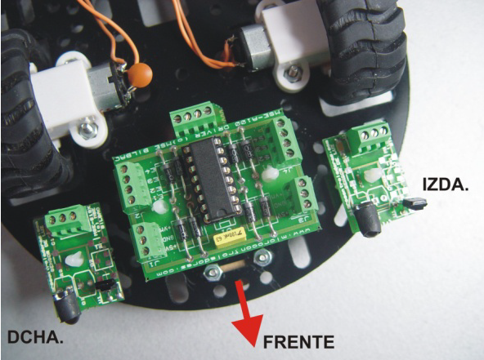
Figure 24. Obstacle sensor connection through robot AzkarBot.
These sensors generate a logical level of “1” whilst on standby, generating a negative value when an obstacle is detected. The left hand side sensor is connected to pin RA3 and the right hand side one to pin RA2 of the PIC18F4550 microcontroller port A.

Reflection sensor
The main challenge of the WebLab-Bot is to develop a program that allows the robot to follow a black line painted on the “tatami” at the maximum speed. The capability of following this line is achieved through two reflection sensors placed on the bottom part of the robot and they indicate us whether they are over a black or white surface. The AzkarBot uses a MSE-S110.2reflection module which includes two CNY70, each having an IR light emisor/receptor. When the light is dispersed or absorbed by a dark surface, the corresponding device output, after being adapted, is of level 1. However, when the light is reflected over a light surface, a logical signal with level “0” is generated. Figure 25 shows the connection of module MSE-S110.2 to the AzkarBot robot.
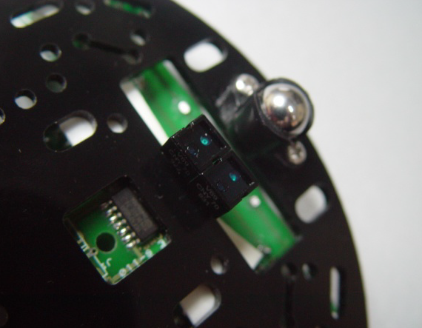
Figure 25. Sensor MSE-S110.2 connected to the lower part of the mobile robot.
The corresponding outputs of the left and right sensors are connected to PIC18F4550 microcontroller’s port A’s RA0 and RA1 pins, respectively.

The Bootloader
A bootloader or load manager is defined in Wikipedia as:
“A simple program which does not have all the functionalities of an operating system and that is designed exclusively to prepare everything needed by an operating system to operate. Normally, the multi-stage bootloaders are used, where several small programs are added to each other, until the last one loads the operating system.”
In the old computers where the permanent memory capacity was very limited and the input and output devices were not that developed, it was common that the program to execute was loaded in volatile memory during machine loading from sequential supports or even punched cards. Nowadays, the use of this type of programs is restricted to microcontrollers. Manufacturers as FreeScale (before Motorola) usually equip all their models with pre-recorded bootloader which allows, during development, to load the program memory with the firmware, directly from the development environment through the serial port. Microchip, for all the PIC18 family microcontrollers, provides an application (AN851) on which the bootloader used in WebLab-Bot is based.
Whenever defining the operation of a remote lab, one of the main directives is to allow the user to develop the experimentation as if she was in an actual lab. Obviously, remotely is impossible to achieve that the experimentation is developed in an identical manner. Whenever a person has a mobile robot, whenever the program controlling it is updated, the mobile robot microcontroller must be reprogrammed to introduce the new firmware version in the program memory. For that, a hardware programmer physically connected to the microcontroller must be used, trough a simple software application in charge of undertaking the programming. Logically, this process cannot be developed remotely through a standard programmer which would have to connected, continuously, to the mobile robot, through a 6 thread cable used for PIC microcontroller programming, thus impeding the robot free movement. The best solution is to undertake the programming of the PIC remotely. A special purpose bootloader, through Bluetooth, without using any cables, receives through an USART port the new program versions sent by users and after placing them in program memory, they launch their execution.
A key feature in a bootloader is the room taken in the program memory. The bootloader used in WebLab-Bot uses the first 512 positions of program memory of the PIC18F4550 microcontroller which controls the robot movement. This implies to alter the addresses of the vector reset and interruption, being originally in that range.
The “reset vector” is the program memory address loaded in the program counter when a “Reset” is provoked. This is, the “reset vector” is the address of the first instruction that is executed after a reset is provoked or a microcontroller is fed. The address “0” in PIC18F4550 microcontroller is “occupied” by the bootloader. The programmer has to start her program in address 0x200, since this address is where the bootloader jumps, after loading a new firmware in the microcontroller’s program memory. Since the interruptions will be studied in an advanced course about microcontrollers, the management of them through the bootloader will be studied there.
Figure 26. Bootloader Sequence.

The operation of the Bootloader is very simple, after the microcontroller is reset, the bootloader is executed and waits to receive from the Bluetooth transceiver, through a serial port, the programming initiation command. This command is sent by the server to the lab when a logged user in the remote laboratory requests a firmware to the microbot.
After the programming init program is launched, the lab server sens to the bootloader all the user program instructions which are loaded in the corresponding positions. When the transferred program has been sent completely, the lab server sends the end of programming command and the bootloader returns the control to the program uploaded by the user that starts to control the mobile robot. This process can be observed in Figure 26.

Access to the Weblab-Bot remote lab
The first step to access the remote lab is to authenticate in the WebLab-Deusto platform, that as indicated before, undertakes the lab management and user control tasks. For that, we access to the Weblab Deusto site at address www.weblab.deusto.es and in the upper menu we select the option “Use WebLab-Deusto Now” which opens the initial page to support platform of the remote labs in the University of Deusto, where we have to authenticate. The user and password used in the ePragmatic site should serve for authentication, otherwise send an email to Ignacio.angulo@deusto.es. Once authenticated, the platform will show the remote lab list to which the user has access. If you are registered to the present course, accesses to the labs associated with the WebLabBot experiment should appear. Figure 27 shows the list of available labs for a given user.
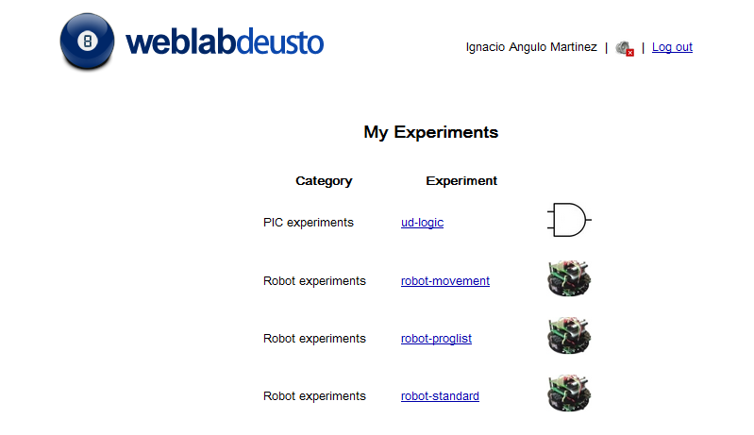
Figure 27. List of opened remote laboratories in WebLab-Deusto Platform.
As observed in the figure, the user has to have access to at least three experiments related to the WebLab-Bot: “robot-movement”, “robot-proglist” and “robot-standard”. They are not three distinct experiments, but three forms of accessing the WebLab-Bot:
- robot-movement: Accessing through this experiment the user will be able to move the robot through the tatami by means of a control which appears in the browser and provokes the robot movement forward, backward or its turns.
- robot-proglist: By means of this access mode, the user will simply select among a series of sample programs preloaded in the server. Programs that show how to randomly move without impacting, line following or turns in both directions can be tested in this mode.
- Robot-standard: In this mode, the user can launch its own program to the robot to test its operation through the camera. This is the mode used in the current course.
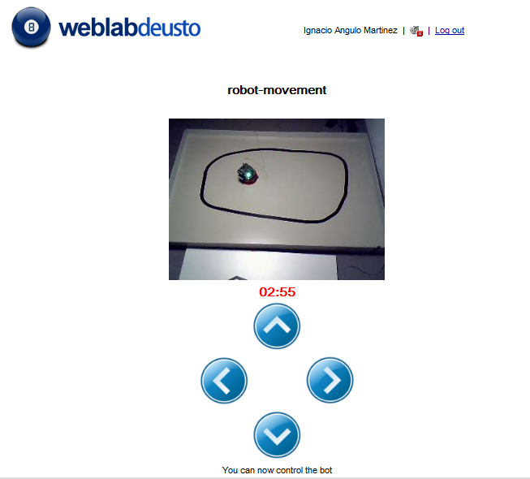 | 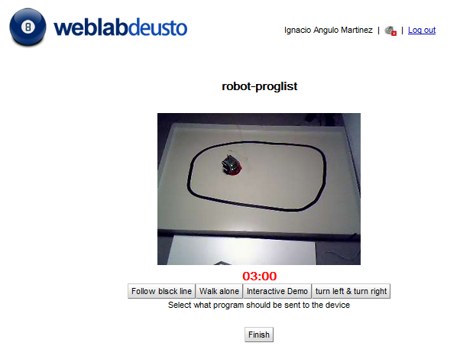 | 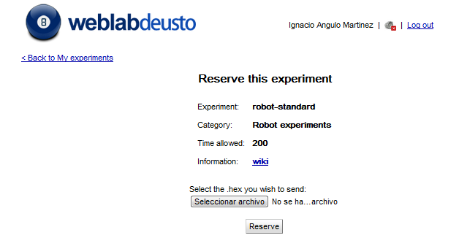
Figure 28. Different access modes for WebLab-Bot.

Experiment 1: Moving the robot

Introduction
This experiment is a tutorial which will guide the student in the development of the first project capable of controlling the robot movement with the intention of allowing it to continously move through the tatami without collapsing against its walls.
This tutorial will use, as unique microcontroller resources the digital inputs and outputs. All the process since the student opens the development environment until she observes the movement of the robot is documented in as much details as possible.

Development of the project with MPLAB IDE

Installing the development environment
This powerful development environment can be freely downloaded from the following URL: www.microchip.com/mplab . Although Microchip is developing a new version named MPLAB X IDE which provides new functionalities and improves the graphical interface, due to its BETA status when developing this module, it is advised to make use of the classic development environment, which can be downloaed from the bottom part of the page. When this module was developed, this software solution version was v8.76. The continuous evalution of the Microchip product catalogue caused that new versions appear frequently. Therefore, it is possible that the version downloaded by the student does not match the one used in the following documents or with the one used in the remote virtual machine, without this having any importance. In this course, we will not explain this development environment, whose use is studied in the basic module about 8 bit microcontrollers included in the ePragmatic project.

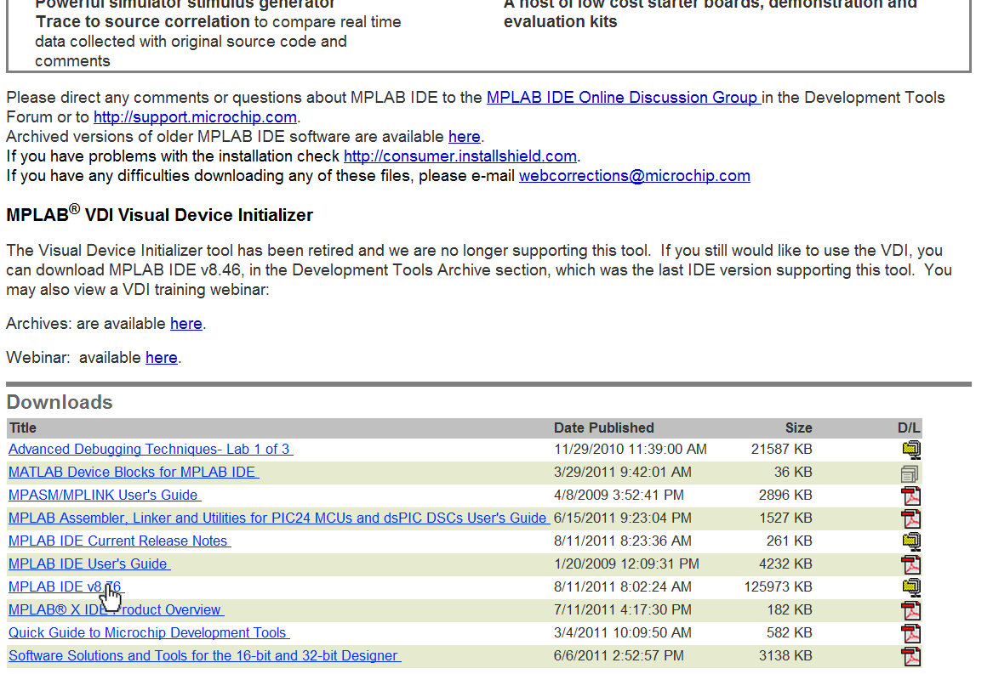
Figure 29. Download of the MPLAB IDE.
The development environment is downloaded in a compressed .zip that internally has the installation file setup.exe. It is recommended that the student undertakes the installation with default options.

Generating a new project with MPLAB
Although the project to be developed in this tutorial is very simple and it is going to be generated through a single file, the MPLAB IDE development environment requires the creation of a project which includes the different source files, headers and so on, that may compose a complex application. It is important to define each project in a different folder.
The first step is to launch the MPLAB IDE development environment through the direct access created after the installation at Start All programs Microchip MPLAB IDE 8.XX. Figure 30 shows the MPLAB IDE graphical interface after its opening. It is possible that the version used for the tutorial development differs from the one used by the user, without this causing significant differences.
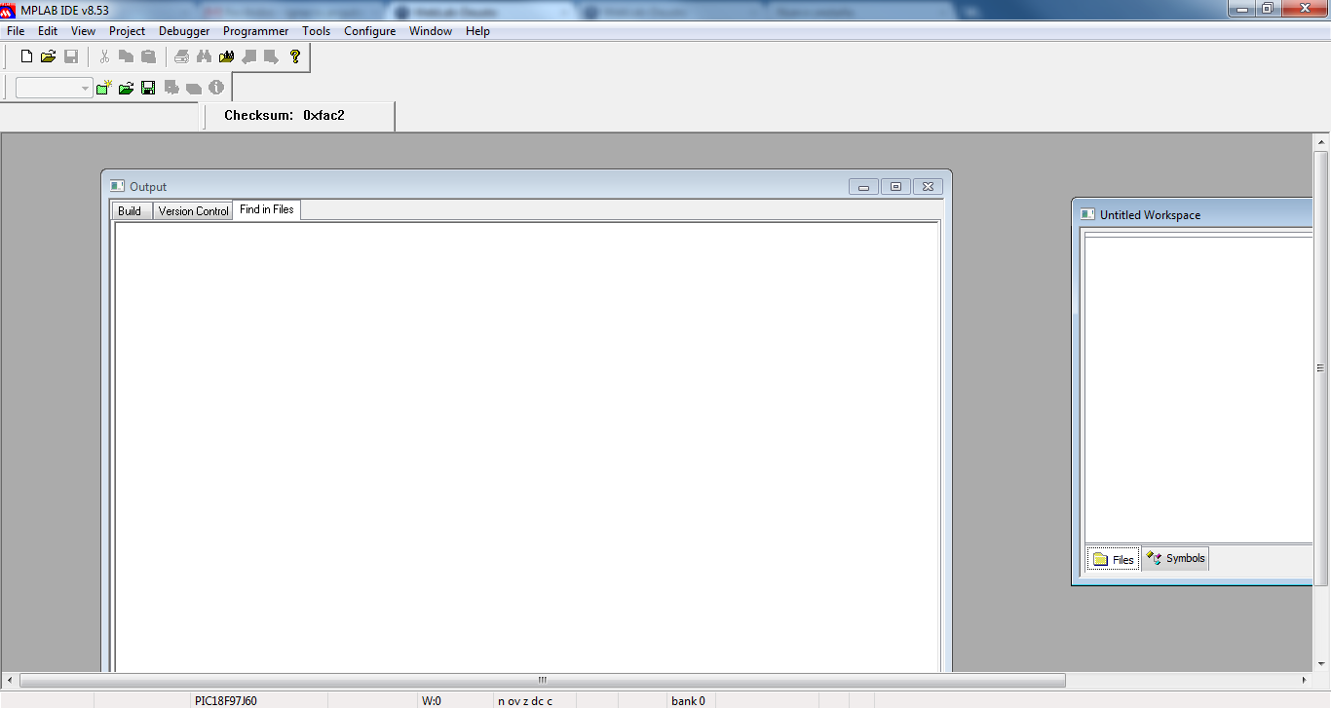
Figure 30. MPLAB IDE GUI.
The simplest option to generate a project is to use the wizard included with this goal. To launch the wizard we select the option Project Wizard… of the Project menu. This wizard will ask us the core functions to bear in mind when generating a project and is in charge of its correct execution. Figure 31 shows the 6 different steps followed in the generation of a project with the suitable options to develop programs for the WebLAb-Bot. It is important to point out that the PIC18F4550 microcontroller will be used, hence, its programming will be carried out through the Microchip assembler. In the penultimate step, the wizard will ask whether we are going to employ any existing file in our project. In that case, it is usual to include the resource libraries which are going to be used in the project, as will be seen in the advanced course. However, in this case it is not necessary to add any additional file. The user can observe in the 4th step in Figure 31 how the project will be named Experiment1, and the folder Experiment1 will be created (c:\ePragmatic\MPUIntro\Experiment1\Experiment1). The student must remember that is convenient to define a folder for each project.
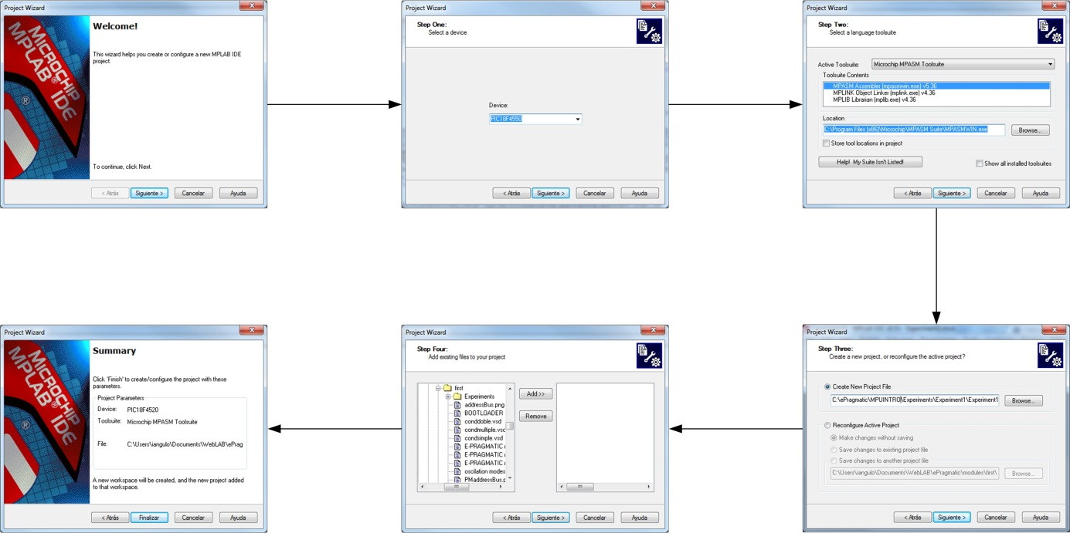
Figure 31. 6 steps generating a project in MPLAB.
Once the project has been generated, the project window will appear with the folders completely empty. In the case that it does not appear, we will have to activate it by going to option Project in menu View. Figure 32 shows the project window when the project is created.
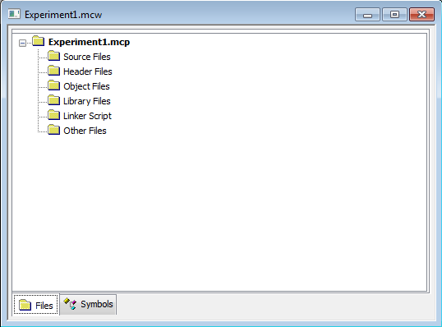
Figure 32. Empty Project Window.

Programming the robot

Generating the source file and giving it a name
Once the project has been generated, we can generate the source file in which the algorithm with the mobile robot behaviour will be implemented. For that, we will select the option New in menu File. It is convenient to record it in the project folder once it has been generated under a name (in this case“main”, since it is the main and unique file) and with the correct extension bearing in mindn the tool used for its development. In this course we will use the assembler language, therefore its extension will be “asm”. Therefore, the file name will be “main.asm”. The MPLAB IDE includes a powerful editor that provides advanced options only useful if we indicate, by means of the extension, the type of files that we are generating. To save the file we choose the first option Save As of Menu File, as observed in Figure 33. Further to choosing the project folder (c:\ePragmatic\MPUIntro\Experiment1) the user should not forget the checking option Add File To Project so that the file is automatically linked to the project. In case of not checking this box, the user will have to do it manually by clicking with the right button of the mouse over the project’s Source Files folder in the project window and selecting the option Add FileTo Project.
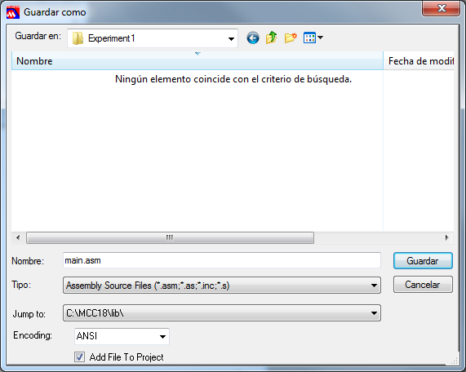
Figure 33. Saving Source File.
The user will observe that when storing the source file, this is added to the folder Source Files in the project.

Initial directives
Before starting with the program instructions, it is paramount to include, at the beginning of the source file, a reference to the header file of the microcontroller being used. This allows us to refer to the microcontroller resources by their name, instead of the address they occupy in the data memory. During the installation of the MPLAB development environment, a folder has been generated including the header files of all the Microchip microcontroller models. The convention used has been to precede the micontroller model by a “p” and adding the extension “.inc”. Thus, the first program line will be:
Include “p18F4550.inc” ;including the header file of PIC 18F4550
Optionally, it is common to indicate the number base to be used by default. In the PIC assembler every time that a literal is referenced, its base is given by preceding it with a “.” If decimal, “0x” if expressed in hexadecilam and “b’” if the literal is codified in binary. For example, .255, 0xFF and b’11111111’ represent the same value in decimal, hexadecimal and binary, respectively. The radix directive allows to select the default number base. Hence, whenever this is not specified the default one will be taken. For instance, through the “Radix hex” directive we indicate that the literals without specified base are codified in hexadecimal.
Radix hex ; Unspecified literal hexadecimal-encoded
After the previously specified directives, the labels and definitions used in the program are given. In this experiment we will use two engines with two separate poles that allow you to indicate the direction of rotation of the motor and the sensors obstacles on the left and the right. For that, we declare the following definitions that will allow us to refer to the digital inputs and outputs without having to refer to the port to which they are connected.
#define motorLeftFwd PORTC,1 ;Forward bit of left Motor
#define motorLeftBck PORTC,0 ;Back bit of left Motor
#define motorRightFwd PORTD,3 ;Forward bit of right Motor
#define motorRightBck PORTC,2 ;Back bit of right Motor
#define obstacleLeft PORTA,2 ;Right obstacle sensor
#define obstacleRight PORTA,3 ;Left obstacle sensor
During the program, these labels will be replaced in the assembler by the value assigned through the directive “equ”.
Once the labels are indicataed we will start with the program. It is necessary to indicate the address where the first instruction of a program will be placed, by means of the directive “org”.

En un laboratorio presencial en el que la programación del MPU se lleva a cabo mediante un programador hardware, la dirección la primera instrucción debe coincidir con el vector de reset, ubicado en la posición 0. Debido al empleo del bootloader del WebLAbBot, la dirección inicial debe alojarse en la posición 200h. Esto se indica mediante la siguiente directiva
Org 0x200 ; Program begins at address 0x200

Configurando el microcontrolador
Antes de ponernos a codificar el algoritmo que debe controlar al robot es necesario configurar los recursos que vamos a utilizar del microcontrolador e incluso, alguno que no vamos a utilizar en este programa. En esta fase se deben configurar los puertos digitales empleados en el control de los motores y los sensores de obstáculos.
La configuración de los puertos digitales en los microcontroladores PIC de la familia 18, se lleva a cabo por medio de tres registros de propósito específico. Son los registros TRIS, PORT y LAT de cada puerto. El PIC18F4550 tiene 5 puertos digitales, cuatro de 8 líneas (A, B, C y D) y un último con únicamente 4 líneas. Todas las líneas de cada puerto pueden ser configuradas individualmente como entradas o salidas. Este es el propósito de los registros TRIS. Cada puerto tiene asociado un registro TRIS (TRISA, TRISB, TRISC, TRISD y TRISE) en el que cada bit del registro define el sentido de una línea del puerto. Un “1” indica que la línea es entrada y un “0” la configura como salida. Por ejemplo si queremos configurar el puerto B con sus 4 líneas de más peso (RB7, RB6, RB5, RB4) como entrada, y las 4 líneas de menos peso como salida, deberemos cargar con un “1” (entrada) los cuatro bits de más peso del registro TRISB y con un “0” (salida) los cuatro de menos peso. Esto se observa en el siguiente ejemplo.
Ejemplo:
Movlw b’11110000’ ;Cargamos en el acumulador el valor binario 1111000
Movwf TRISB ;Escribimos el valor en el registro TRISB, configurando
; RB7, RB6, RB5 y RB4 como entradas y
; RB3, RB2, RB1 y RB0 como como salidas.
En el programa que se desarrolla mediante este tutorial debemos configurar los motores como salida y los sensores de obstáculos como entradas. El código es el siguiente:
Movlw b’11111000’
movwf TRISC ;RC0, RC1 y RC2 sets as OUTPUTS
Movlw b’111101110
movwf TRISD ;RD3 set as OUTPUT (Motor ports set as outputs)
setf TRISA ;full PORTA set as INPUT (including sensors)
Observe el usuario que las líneas no empleadas de los puertos suelen configurarse como entradas. Esto se debe a que la intensidad de salida de cada puerto se divide entre las líneas configuradas como salida.
Las patitas del microcontrolador asociadas a los puertos de entrada/salida, se encuentran habitualmente multiplexadas con otros recursos. Por ejemplo se puede observar en la figura 34, que representa el diagrama de pines del PIC18f4550, como la patita RC1 mediante la que se controla el motor, está multiplexada con otras dos funciones T1OSI (entrada del oscilador externo asociado al Timer 1) y CCP2 (patita asociada al módulo 2 de captura comparación y PWM). Por este motivo suele ser necesario la configuración de recursos que no se emplean en el propio programa.
Figura 34.- PIC18F4550 pin diagrams
Para el programa que estamos desarrollando en este tutorial, en el que se emplean los puertos C y A, es conveniente deshabilitar el comparador #1 y definir las entradas del puerto A como digitales. Aunque estos recursos se estudian en el curso avanzado, el alumno puede llevar a cabo esas acciones incluyendo las siguientes líneas:
movlw 0x0f
movwf ADCON1 ;All ports digitals
movlw 0x07
movwf CMCON ;Comparators Off

Controlando el robot
Una vez se ha configurado el microcontrolador, es el momento de codificar en ensamblador el algoritmo que queremos que controle el movimiento del robot. Este algoritmo es muy sencillo, el robot avanzará mientras no encuentre obstáculos. En el momento que detecte un obstáculo a la derecha girará a la izquierda hasta que desaparezca y cuando el obstáculo aparezca a la izquierda se girará a la derecha. Para la programación en ensamblador es útil modelizar el programa mediante un diagrama de flujo. La figura 35 muestra el diagrama de flujo correspondiente al algoritmo indicado.
Figura 35.- Experiment 1 flow diagram.
Como se observa en el diagrama de flujo, una vez llevadas a cabo las tareas de configuración, el primer paso es forzar el avance del robot. Para ello debemos activar los polos de los motores que provocan el avance y han sido etiquetados como motorRightFwd y motorLeftFwd y desactivar los polos que se encargan de hacer los motores retroceder: motorRightBck y motorLeftBck.
goForward Bsf motorRightFwd
bsf motorLeftFwd
bcf motorRightBck
bcf motorLeftBck
En el diagrama de flujo se observa que al proceso de avanzar llega una flecha desde otro punto del diagrama. Esto significa que más adelante deberemos provocar un salto a este punto. Por tanto definimos la etiqueta goForward al comienzo del proceso. Para definir una etiqueta en el programa simplemente basta con colocarla antes de la instrucción que referencia.
Una vez el robot avanza el siguiente paso es comprobar si se detectan obstáculos a la derecha. A este proceso llega una flecha, luego exige definir una etiqueta. Este proceso es condicional y en caso de que se detecte un obstáculo a la derecha, deberemos saltar a otro proceso “girar a la izquierda”. El alumno debe recordar del capítulo anterior que los sensores de obstáculos del robot AzkarBot emiten un “1” lógico en reposo y un “0” si se produce la detección. En caso de que no se detecte ningún obstáculo el programa debe continuar. Para la condición emplearemos la instrucción “btfss” esta instrucción comprueba un bit de un registro y produce un salto cuando su valor es uno.
detectRight btfss obstacleRight ; if sensor is “1” skip next instruction (no detect)
bra turnLeft ; if previous instruction does not jump turn left
; to avoid de obstacle detected
El mismo proceso se llevará a cabo con el sensor de obstáculos por la izquierda.
detectLeft btfss obstacleLeft ; if sensor is “1” skip next instruction (no detect)
bra turnRight ; if previous instruction does not jump turn Right
; to avoid de obstacle detected
Finalmente, si no detectamos ninguno de los sensores, volvemos a avanzar.
Bra goForward ;
Para acabar, tenemos que codificar los procesos referidos para girar a la izquierda (turnLeft) y a la derecha (turnRight). Cuando estos finalizan, como se observa en el flujo de datos vuelven a saltar a la comprobación pertinente.
turnLeft Bsf motorRightFwd
bcf motorLeftFwd
bcf motorRightBck
bcf motorLeftBck
bra detectRight
turnRight Bcf motorRightFwd
bsf motorLeftFwd
bcf motorRightBck
bcf motorLeftBck
bra detectLeft
Por último, todo proyecto debe incluir la directiva “END” al final del mismo que indica al ensamblador que su trabajo ha concluido.
END
El aspecto final del fichero fuente se muestra en la tabla 16.
include "p18F4550.inc" ; including the header file of PIC 18F4550
radix hex ; Unspecified literal hexadecimal-encoded

;********************************Label Definition***************************************
#define motorLeftFwd PORTC,1 ;Forward bit of left Motor
#define motorLeftBck PORTC,0 ;Back bit of left Motor
#define motorRightFwd PORTD,3 ;Forward bit of right Motor
#define motorRightBck PORTC,2 ;Back bit of right Motor
#define obstacleLeft PORTA,2 ;Right obstacle sensor
#define obstacleRight PORTA,3 ;Left obstacle sensor

Org 0x200 ; Program begins at address 0x200
;********************************Configuration Section***************************************
movlw b'11111000'
movwf TRISC ;RC0, RC1 y RC2 sets as OUTPUTS
movlw b'11110111'
movwf TRISD ;RD3 set as OUTPUT (Motor ports set as outputs)
setf TRISA ;full PORTA set as INPUT (including sensors)
movlw 0x0f
movwf ADCON1 ;All ports digitals
movlw 0x07
movwf CMCON ;Comparators Off

;********************************Program Starts***************************************
goForward bsf motorRightFwd
bsf motorLeftFwd
bcf motorRightBck
bcf motorLeftBck

detectRight btfss obstacleRight ; if sensor is “1” skip next instruction (no detect)
bra turnLeft ; if previous instruction does not jump turn left
; to avoid de obstacle detected

detectLeft btfss obstacleLeft ; if sensor is “1” skip next instruction (no detect)
bra turnRight ; if previous instruction does not jump turn Right
; to avoid de obstacle detected
bra goForward

turnLeft bsf motorRightFwd
bcf motorLeftFwd
bcf motorRightBck
bcf motorLeftBck
bra detectRight

turnRight Bcf motorRightFwd
bsf motorLeftFwd
bcf motorRightBck
bcf motorLeftBck
bra detectLeft

end
Tabla 16.- Experiment 1 source code.

Probando el experimento en el laboratorio remoto
Una vez hemos terminado de editar el programa, lo siguiente es probarlo en el laboratorio remoto. Antes de poder enviárselo al robot, es necesario generar el ejecutable. Aunque hayamos desarrollado el programa en lenguaje de bajo nivel (ensamblador), aún no es interpretable por el micro. El ensamblador ofrecido gratuitamente por microchip, que se seleccionó en la definición del proyecto, se encarga de transforma en código ensamblador a código máquina. Basta con seleccionar la opción Build All del menú Project o pulsar en el icono en la barra de herramientas del MPLAB IDE. Si la compilación es correcta se verá una ventana de salida como la representada en la figura 36.
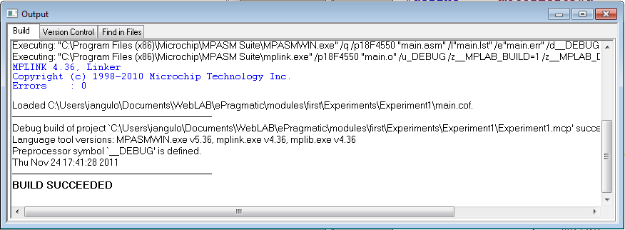
Figura 36.- Program succesfully assembled.
Una vez generado el fichero binario podemos probarlo en el robot. Para ello debemos autenticarnos en la plataforma WebLab-Deusto (como se ha visto en el capítulo 4 de este curso) y seleccionar el experimento robot-standard. La ventana inicial del experimento permite seleccionar el archivo binario que ha sido generado durante el ensamblado. Este archivo se encuentra en la carpeta del proyecto con el mismo nombre que el fichero fuente que contiene el programa principal y extensión “.hex”. Si el alumno ha seguido los pasos de este tutorial, el fichero fuente deberá llamarse “main.hex”. la figura 37 muestra la ventana inicial del experimento.

Figura 37.- Selecting binary file in robot-standard experiment.
Ya está…. Cruzar los dedos y pulsar el botón Reserve. El robot será grabado con tu firmware y comenzará a andar por el tatami sin chocarse. Puedes observar el funcionamiento con la WebCam como se observa en la figura 38.
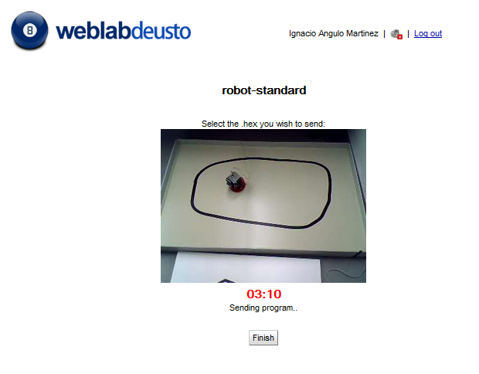
Figura 38.- Sending Firmware to WebLab-Bot.

Solucionando el desastre


Figura 39.- Crash, Boom, Bang, Bam.
Desastre, pese a nuestro aparentemente perfecto algoritmo… el robot avanza hasta chocarse contra la pared. Programando en ensamblador, es habitual que un programa no funcione a la primera. Lejos de rendirnos, lo que toca es detectar las causas del fallo y corregirlas en un nuevo intento. Recomendamos emplear el experimento robot-movement para recolocar al robot en el centro el tatami antes de un nuevo intento. En esta ocasión, el fallo del algoritmo radica en que la detección de las paredes no se produce hasta que el robot se encuentra a unos 5cm de las mismas. De esta forma, aunque comienza a girar al detectar la colisión no gira lo suficientemente rápido como para evitar la colisión.
Primera solución propuesta: Girar más rápido. En lugar de parar la rueda derecha para girar en ese sentido y viceversa. Si hacemos que la rueda gire en sentido contrario, el robot girará sobre sí mismo a mayor velocidad. Los cambios necesarios afectan a las rutinas turnLeft y turnRight:
turnLeft bsf motorRightFwd
bcf motorLeftFwd
bcf motorRightBck
bsf motorLeftBck
bra detectRight
turnRight Bcf motorRightFwd
bsf motorLeftFwd
bsf motorRightBck
bcf motorLeftBck
bra detectLeft
Una vez realizados los cambios, volvemos a construir el proyecto y lo volvemos a lanzar sobre el experimento remoto. Esta vez observamos un comportamiento como el capturado en el siguiente video:
Sustituir por Video 2 ePragmatic\modules\first\ prueba1Mejorada.avi

Video 2.- Experiment 1, second try.
Inicialmente el robot funciona correctamente, pero llega un momento en el que se bloquea en una esquina. Razón: El área de captura de los sensores de obstáculos y no los detecta cuando el robot circula en paralelo a la pared o encuentra una esquina.
Segunda Solución Propuesta: En lugar de girar sólo hasta que el sensor deja de detectar el obstáculo, provocar un giro mayor que evite las causas identificadas. Para ello necesitamos una rutina que se encargue de temporizar un periodo de aproximadamente ½ segundo (unos 100º de giro en el robot). Idealmente esa temporización se debe llevar a cabo mediante los temporizadores, sin embargo, dado que ese recurso se estudia en el curso avanzado, generaremos unos bucles anidados que se encargarán de perder tiempo. El proceso que vamos a codificar en ensamblador se expresaría en alto nivel más o menos de la siguiente forma:

For (temp1 = 0; temp1 <8; temp1--)
For (temp1 = 0; temp1 <256; temp1 ++)
For (temp2 = 0; temp2 <256; temp2 ++)
El propósito de la rutina es mantener al micro decrementando counteres durante ½ segundo.La codificación en ensamblador queda de la siguiente forma:
halfSec Movlw .3
movwf temp1
clrf temp2
clrf temp3 ; Init vars (temp0=8, temp1=0 y temp2=0)
bucle1 decfsz temp1, F ; First loop is repeated 8 times.
bra bucle2
return
bucle2 decfsz temp2, F ; Second Loop is repeated 256 times for each
bra bucle3 ;iteration of the first loop
bra bucle1
bucle3 decfsz temp3, F ; Third bucle is repeated 256 times for each
bra bucle3 ;iteration of the second loop
bra bucle2

Considerando que cada bucle tarda 3 ciclos internos de reloj (1 salto + 1 decremento), la rutina tarda
3 * 256 * 256 * 3 = 589825 ciclos. Como 1 ciclo tarda 1µs, La duración de la rutina es aproximadamente 0.6 s.
Es necesario definir las variables temp1, temp2 y temp3 al principio del programa. En este caso se asociarán los registros 00h a la variable temp1, 01h a la variable temp2 y 02h a la variable temp3. La declaración quedaría dela forma siguiente:
temp1 equ 0x00 ;variable temp1 asociada a registro 0x000 de prop. General
temp2 equ 0x01 ;variable temp2 asociada a registro 0x001 de prop. General
temp3 equ 0x02 ;variable temp3 asociada a registro 0x002 de prop. general
El alumno debe recordar que en todo momento se accede a la memoria de datos a través del banco de acceso. Además será necesario llamar a la rutina cada vez que se detecte un obstáculo. El código final queda como se refleja en la tabla 17.
#define motorRightFwd PORTC,2 ;Forward bit of right Motor
#define motorRightBck PORTD,3 ;Back bit of right Motor
#define obstacleLeft PORTA,3 ;Right obstacle sensor
#define obstacleRight PORTA,2 ;Left obstacle sensor

temp1 equ 0x00 ;variable temp1 asociada a registro 0x000 de prop. General
temp2 equ 0x01 ;variable temp2 asociada a registro 0x001 de prop. General
temp3 equ 0x02 ;variable temp3 asociada a registro 0x002 de prop. general

Org 0x200 ; Program begins at address 0x200
;********************************Configuration Section***************************************
movlw b'11111000'
movwf TRISC ;RC0, RC1 y RC2 sets as OUTPUTS
movlw b'11110111'
movwf TRISD ;RD3 set as OUTPUT (Motor ports set as outputs)
setf TRISA ;full PORTA set as INPUT (including sensors)
movlw 0x0f
movwf ADCON1 ;All ports digitals
movlw 0x07
movwf CMCON ;Comparators Off

;********************************Program Starts***************************************
goForward bsf motorRightFwd
bsf motorLeftFwd
bcf motorRightBck
bcf motorLeftBck
detectRight btfss obstacleRight ; if sensor is “1” skip next instruction (no detect)
bra turnLeft ; if previous instruction does not jump turn left
; to avoid de obstacle detected

detectLeft btfss obstacleLeft ; if sensor is “1” skip next instruction (no detect)
bra turnRight ; if previous instruction does not jump turn Right
; to avoid de obstacle detected
bra goForward ;

turnLeft Bsf motorRightFwd
bcf motorLeftFwd
bcf motorRightBck
bsf motorLeftBck
rcall halfSec ;Wait 0,6s
bra detectRight

turnRight Bcf motorRightFwd
bsf motorLeftFwd
bsf motorRightBck
bcf motorLeftBck
rcall halfSec ;Wait 0,6s
bra detectLeft

halfSec Movlw .3
movwf temp1
clrf temp2
clrf temp3 ; Init vars (temp0=8, temp1=0 y temp2=0)
bucle1 decfsz temp1, F ; First loop is repeated 8 times.
bra bucle2
return
bucle2 decfsz temp2, F ; Second Loop is repeated 256 times for each
bra bucle3 ;iteration of the first loop
bra bucle1
bucle3 decfsz temp3, F ; Third bucle is repeated 256 times for each
bra bucle3 ;iteration of the second loop
bra bucle2
;considering that each loop takes 3 cycles internal clock
;(1 jump + 1 decrease), the loop takes 3 * 256 * 256 * 3 = 589825
;as 1 cycle is 1 us, rutine takes aprox. 0.6 s

End
Tabla 17.- Source Code of the Experiment1.
Solo falta generar el archivo binario y volver a probarlo en el experimento robot-estándar.

Figura 40.- Yeahhhhhh.
Finalmente a la tercera va la vencida. El robot se desplaza por el tatami esquivando las paredes.

Experimento 2.- La línea negra
En este experimento el alumno es retado a desarrollar un nuevo proyecto. Conseguir que el robot siga la línea negra dibujada en el tatami. Para ello deberemos usar, no solo los sensores de obstáculos, para evitar choques, sino también los sensores de reflexión para detectar si el robot se encuentra sobre la línea negra.
Se recomienda al alumno desarrollar el proyecto en dos fases:
Fase 1ª: Partiendo del proyecto desarrollado en el experimento 1, añadir los cambios necesarios para que el robot se detenga cuando los dos sensores de reflexión detecten superficie negra. Es decir, que el robot se encuentra sobre la línea negra.
Fase 2ª: Una vez el robot se encuentra sobre la línea negra el alumno debe conseguir que circule siguiendo a esta. Para ello comprobaremos si el robot se sale por la derecha o izquierda, corrigiendo el movimiento en cada caso.
El alumno no debe dudar en preguntar al profesor a través del portal ePragmatic.

